Name: Valli Karthik
Reg.No: 192324258
SLOT B - DSA0402- FUNDAMENTALS OF DATA SCIENCE
CO3 AT3
CASE STUDY 1 – E-Commerce Customer Analysis
Problem Understanding
An e-commerce company has collected customer transaction data, including purchase amount, number of orders, browsing time, and customer ratings. The company wants to understand customer purchasing behavior and improve its marketing strategies. The objectives are to summarize customer transaction data, detect unusual purchasing patterns, and determine whether premium members spend significantly more than regular customers using statistical analysis.

Application of Data Science Concepts
This case study applies several data science concepts:
- Descriptive Statistics: Summarizes customer purchase amounts, orders, browsing time, and ratings using measures such as mean, median, standard deviation, and quartiles.
- Distribution Analysis: Examines whether purchase amounts follow a normal or skewed distribution.
- Outlier Detection: Identifies unusually high or low purchase amounts using statistical methods.
- Statistical Inference: Uses hypothesis testing to compare spending behavior between premium and regular customers.
These techniques help businesses make informed decisions regarding customer segmentation and marketing strategies.

Descriptive Statistics and Distribution Analysis
Descriptive statistics provide a summary of customer transaction data.
Mean
The mean represents the average purchase amount.
Formula
$$\overline{x}=\frac{\sum{x}}{n}$$
A higher mean indicates that customers generally spend more per transaction.

Median
The median is the middle value after arranging purchase amounts in ascending order.
It is useful because it is less affected by extremely high purchase amounts than the mean.

Standard Deviation
The standard deviation measures how much purchase amounts vary from the average.
Formula
$$s=\sqrt{\frac{\sum{(}\left.x-\overline{x}{\left.)\right.}^{2}\right.}{n-1}}$$
- Small standard deviation → Customers spend similar amounts.
- Large standard deviation → Customer spending varies widely.

Quartiles
Quartiles divide the data into four equal parts.
- Q1 (25%)
- Q2 (Median)
- Q3 (75%)
Quartiles help identify spending patterns and are useful for outlier detection.

Distribution Analysis
The purchase amount distribution can be analyzed using:
- Histogram
- Density Plot
- Box Plot
Possible observations:
- Normal Distribution: Most customers spend around the average.
- Right-Skewed Distribution: A few customers make very expensive purchases.
- Left-Skewed Distribution: Rare in e-commerce but possible during heavy discount periods.
Understanding the distribution helps the company design pricing and promotional strategies.

Outlier Detection and Interpretation
Some customers may have extremely high or extremely low purchase amounts.
Examples:
- Bulk corporate purchases.
- Fraudulent transactions.
- Incorrect data entry.
- Refund or cancellation errors.
These values can distort statistical analysis.

Methods for Detecting Outliers
1. Box Plot
A box plot visually identifies values outside the normal range.

2. Interquartile Range (IQR) Method
Formula
$$IQR=Q3-Q1$$
Lower Limit
$$Q1-1.5\left(IQR\right)$$
Upper Limit
$$Q3+1.5\left(IQR\right)$$
Any value outside these limits is considered an outlier.

3. Z-Score Method
Formula
$$Z=\frac{x-\overline{x}}{s}$$
If
$$∣Z∣>3$$
the observation is considered an outlier.

Interpretation
Outliers should not always be removed.
Instead,
- Verify whether the transaction is genuine.
- Investigate possible fraud.
- Separate premium business customers from regular customers.
- Correct data entry errors if necessary.

Statistical Inference (Hypothesis Testing)
The company wants to determine whether premium members spend significantly more than regular customers.

Hypotheses
Null Hypothesis
$$H_{0}:μ_{premium}=μ_{regular}$$
There is no significant difference in average spending.

Alternative Hypothesis
$$H_{1}:μ_{premium}>μ_{regular}$$
Premium members spend significantly more than regular customers.

Testing Procedure
- Collect purchase amounts for both customer groups.
- Calculate sample means and standard deviations.
- Select an appropriate significance level (usually α = 0.05).
- Perform an Independent Sample t-test.
- Calculate the p-value.
- Compare the p-value with α.
Decision Rule:
- If p < 0.05, reject the null hypothesis.
- If p ≥ 0.05, fail to reject the null hypothesis.

Analysis of Results
If the statistical test shows that premium customers spend significantly more, the company can conclude that premium membership positively influences customer spending.
If no significant difference is found, other factors such as discounts, browsing behavior, or product preferences may have a stronger impact on purchases.

Practical Recommendations
- Introduce exclusive offers for premium members.
- Provide personalized product recommendations based on browsing history.
- Monitor unusual purchase behavior to detect fraud.
- Use customer segmentation for targeted marketing campaigns.
- Reward loyal customers with discounts and cashback offers.
- Regularly analyze purchasing trends to improve inventory planning.

Conclusion
Descriptive statistics provide a clear summary of customer purchasing behavior, while outlier detection helps identify unusual transactions that may affect analysis. Hypothesis testing enables the company to determine whether premium membership significantly influences spending. Applying these data science techniques helps improve customer segmentation, marketing strategies, and overall business performance.

Suggested Visualizations
- Histogram of Purchase Amount
- Box Plot of Purchase Amount
- Bar Chart comparing Premium vs Regular Customer Spending
- Scatter Plot of Browsing Time vs Purchase Amount

Python Code
import pandas as pd
import matplotlib.pyplot as plt
from scipy.stats import ttest_ind

# Load dataset
df = pd.read_csv("ecommerce_customer_data.csv")

# Descriptive Statistics
print(df.describe())

# Histogram
plt.hist(df["Purchase_Amount"], bins=10)
plt.title("Purchase Amount Distribution")
plt.xlabel("Purchase Amount")
plt.ylabel("Frequency")
plt.show()

# Box Plot
plt.boxplot(df["Purchase_Amount"])
plt.title("Purchase Amount Box Plot")
plt.show()

# Hypothesis Test
premium = df[df["Membership"] == "Premium"]["Purchase_Amount"]
regular = df[df["Membership"] == "Regular"]["Purchase_Amount"]

t_stat, p_value = ttest_ind(premium, regular)

print("T-Statistic:", t_stat)
print("P-Value:", p_value)

if p_value < 0.05:
print("Reject the Null Hypothesis")
print("Premium members spend significantly more.")
else:
print("Fail to Reject the Null Hypothesis")

Sample CSV Dataset
Customer_ID | Purchase_Amount | Orders | Browsing_Time | Rating | Membership
C001 | 1200 | 3 | 25 | 4.5 | Premium
C002 | 850 | 2 | 18 | 4.2 | Regular
C003 | 1500 | 4 | 30 | 4.8 | Premium
C004 | 600 | 1 | 12 | 3.9 | Regular
C005 | 1800 | 5 | 35 | 4.9 | Premium
C006 | 700 | 2 | 15 | 4.0 | Regular
C007 | 2100 | 6 | 40 | 5.0 | Premium
C008 | 950 | 3 | 20 | 4.3 | Regular
C009 | 1600 | 4 | 32 | 4.7 | Premium
C010 | 750 | 2 | 16 | 4.1 | Regular

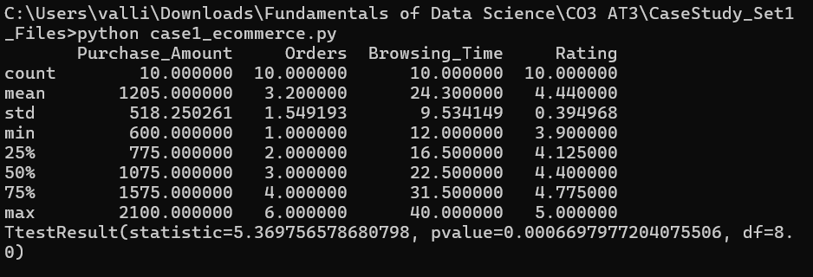

CASE STUDY 2 – Renewable Energy Production Analysis
Problem Understanding
A solar power company has collected data from multiple solar plants, including daily energy generation, sunlight hours, panel temperature, and system efficiency. The company wants to evaluate plant performance and determine whether the average daily energy generation meets the expected target. The analysis involves descriptive statistics, outlier detection, confidence intervals, and hypothesis testing to support operational decisions.

Application of Data Science Concepts
This case study applies the following Data Science concepts:
- Descriptive Statistics: Summarizes daily energy generation, sunlight hours, panel temperature, and efficiency.
- Distribution Analysis: Examines whether energy production follows a normal or skewed distribution.
- Outlier Detection: Identifies abnormal energy generation values caused by equipment failures or weather conditions.
- Statistical Inference: Uses confidence intervals and hypothesis testing to verify whether the average energy generation differs from the expected target.
These techniques help improve plant performance, maintenance planning, and energy forecasting.

Descriptive Statistics and Distribution Analysis
Descriptive statistics summarize the energy production data.
Mean
The mean represents the average daily energy generation across all solar plants.
Formula
$$\overline{x}=\frac{\sum{x}}{n}$$
A higher mean indicates better overall energy production.

Median
The median is the middle value after arranging the daily energy generation values in ascending order.
It is less affected by unusually high or low production values.

Standard Deviation
Standard deviation measures the variation in daily energy generation.
Formula
$$s=\sqrt{\frac{\sum{(}\left.x-\overline{x}{\left.)\right.}^{2}\right.}{n-1}}$$
- Small standard deviation → Stable energy production.
- Large standard deviation → High fluctuations in plant performance.

Quartiles
Quartiles divide the dataset into four equal parts.
- Q1 (25%)
- Q2 (Median)
- Q3 (75%)
Quartiles help understand the spread of energy production and detect unusual values.

Distribution Analysis
The distribution of daily energy generation can be analyzed using:
- Histogram
- Density Plot
- Box Plot
Possible observations:
- Normal Distribution: Energy production is consistent across plants.
- Right-Skewed Distribution: A few plants generate exceptionally high energy.
- Left-Skewed Distribution: Several plants produce below-average energy due to maintenance or weather conditions.
Understanding the distribution helps evaluate plant efficiency.

Outlier Detection and Interpretation
Some plants may record unusually high or low energy production.
Possible causes include:
- Equipment malfunction.
- Cloudy weather.
- Dust accumulation on solar panels.
- Sensor errors.
- Maintenance shutdowns.
These values can affect statistical analysis and forecasting.

Methods for Detecting Outliers
1. Box Plot
A box plot visually identifies unusual energy generation values.

2. Interquartile Range (IQR) Method
Formula
$$IQR=Q3-Q1$$
Lower Limit
$$Q1-1.5\left(IQR\right)$$
Upper Limit
$$Q3+1.5\left(IQR\right)$$
Values outside these limits are considered outliers.

3. Z-Score Method
Formula
$$Z=\frac{x-\overline{x}}{s}$$
If
$$∣Z∣>3$$
the observation is considered an outlier.

Interpretation
Before removing outliers,
- Verify equipment status.
- Check weather conditions.
- Confirm sensor accuracy.
- Determine whether the value represents an actual operational issue.
Outliers caused by genuine equipment failures should be analyzed rather than discarded.

Statistical Inference
The company wants to determine whether the average daily energy generation differs significantly from the expected target.

Hypotheses
Null Hypothesis
$$H_{0}:μ=μ_{0}$$
The average daily energy generation is equal to the expected target.

Alternative Hypothesis
$$H_{1}:μ≠μ_{0}$$
The average daily energy generation differs from the expected target.

Confidence Interval
A 95% confidence interval can be used to estimate the true average energy generation.
Formula
$$CI=\overline{x}±Z\left(\frac{s}{\sqrt{n}}\right)$$
If the expected target lies inside the confidence interval,
there is no significant difference.

Hypothesis Testing Procedure
- Collect daily energy generation data.
- Calculate sample mean and standard deviation.
- Select significance level (α = 0.05).
- Perform a one-sample t-test.
- Calculate the p-value.
- Compare the p-value with α.
Decision Rule:
- If p < 0.05, reject the null hypothesis.
- If p ≥ 0.05, fail to reject the null hypothesis.

Analysis of Results
If the hypothesis test indicates that the average energy generation is significantly lower than the target, maintenance, cleaning, or equipment upgrades may be required.
If no significant difference exists, the plants are operating as expected.

Practical Recommendations
- Regularly clean solar panels to improve efficiency.
- Monitor sunlight hours and weather conditions.
- Schedule preventive maintenance for solar panels and inverters.
- Replace faulty sensors promptly.
- Continuously monitor plant efficiency using dashboards.
- Use predictive analytics to forecast energy production.

Conclusion
Descriptive statistics provide valuable insights into daily energy production and plant performance. Outlier detection helps identify abnormal energy generation caused by environmental or technical factors. Confidence intervals and hypothesis testing enable the company to determine whether average energy production meets the expected target, supporting better operational planning and maintenance decisions.

Suggested Visualizations
- Histogram of Daily Energy Generation
- Box Plot of Energy Production
- Scatter Plot of Sunlight Hours vs Energy Generation
- Line Chart of Daily Energy Production
- Bar Chart of System Efficiency by Plant

Python Code
import pandas as pd
import matplotlib.pyplot as plt
from scipy.stats import ttest_1samp

# Load dataset
df = pd.read_csv("renewable_energy_data.csv")

# Descriptive Statistics
print(df.describe())

# Histogram
plt.hist(df["Energy_Generation"], bins=10)
plt.title("Daily Energy Generation")
plt.xlabel("Energy (kWh)")
plt.ylabel("Frequency")
plt.show()

# Box Plot
plt.boxplot(df["Energy_Generation"])
plt.title("Energy Generation Box Plot")
plt.show()

# One-Sample t-test
target = 500

t_stat, p_value = ttest_1samp(df["Energy_Generation"], target)

print("T-Statistic:", t_stat)
print("P-Value:", p_value)

if p_value < 0.05:
print("Reject the Null Hypothesis")
else:
print("Fail to Reject the Null Hypothesis")

Sample CSV Dataset
Plant_ID | Energy_Generation (kWh) | Sunlight_Hours | Panel_Temperature (°C) | Efficiency (%)
P001 | 510 | 8.2 | 35 | 91
P002 | 495 | 7.8 | 36 | 89
P003 | 520 | 8.5 | 34 | 92
P004 | 480 | 7.5 | 38 | 87
P005 | 530 | 8.7 | 33 | 93
P006 | 505 | 8.1 | 35 | 90
P007 | 515 | 8.3 | 34 | 91
P008 | 490 | 7.7 | 37 | 88
P009 | 525 | 8.6 | 33 | 92
P010 | 500 | 8.0 | 35 | 90

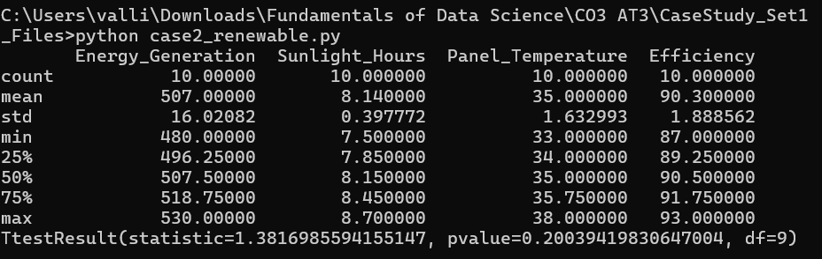

CASE STUDY 3 – Hospital Patient Recovery Analysis
Problem Understanding
A hospital has collected patient recovery data, including age, treatment cost, number of hospital days, recovery time, and patient satisfaction score. The hospital wants to analyze treatment effectiveness, identify unusual recovery patterns, and determine whether patients receiving a new treatment recover faster than those receiving the existing treatment.

Application of Data Science Concepts
This case study uses the following Data Science concepts:
- Descriptive Statistics: Summarizes recovery time, treatment cost, hospital stay, and patient satisfaction.
- Distribution Analysis: Examines whether recovery time follows a normal distribution.
- Outlier Detection: Identifies unusually long hospital stays or expensive treatments.
- Statistical Inference: Uses hypothesis testing to compare recovery times between patients receiving different treatments.
These analyses help hospitals improve treatment quality, reduce healthcare costs, and enhance patient care.

Descriptive Statistics and Distribution Analysis
Descriptive statistics summarize patient recovery data.
Mean
The mean represents the average recovery time or treatment cost.
Formula
$$\overline{x}=\frac{\sum{x}}{n}$$
A lower average recovery time generally indicates more effective treatment.

Median
The median is the middle value after arranging recovery times in ascending order.
It is useful because it is less affected by patients with extremely long hospital stays.

Standard Deviation
Standard deviation measures the variation in recovery time.
Formula
$$s=\sqrt{\frac{\sum{(}\left.x-\overline{x}{\left.)\right.}^{2}\right.}{n-1}}$$
- Small standard deviation → Most patients recover in a similar period.
- Large standard deviation → Recovery times vary significantly among patients.

Quartiles
Quartiles divide recovery times into four equal groups.
- Q1 (25%)
- Q2 (Median)
- Q3 (75%)
Quartiles help identify recovery patterns and detect unusual values.

Distribution Analysis
Recovery time can be analyzed using:
- Histogram
- Density Plot
- Box Plot
Possible observations:
- Normal Distribution: Most patients recover within the expected time.
- Right-Skewed Distribution: A few patients require much longer recovery periods.
- Left-Skewed Distribution: Most patients recover quickly with only a few slow recoveries.
Distribution analysis helps evaluate treatment effectiveness.

Outlier Detection and Interpretation
Some patients may have unusually long recovery times or very high treatment costs.
Possible causes include:
- Serious medical complications.
- Chronic illnesses.
- Delayed diagnosis.
- Surgical complications.
- Incorrect data entry.
These values may influence the overall statistical analysis.

Methods for Detecting Outliers
1. Box Plot
A box plot visually identifies patients with unusually long recovery times or treatment costs.

2. Interquartile Range (IQR) Method
Formula
$$IQR=Q3-Q1$$
Lower Limit
$$Q1-1.5\left(IQR\right)$$
Upper Limit
$$Q3+1.5\left(IQR\right)$$
Values outside these limits are considered outliers.

3. Z-Score Method
Formula
$$Z=\frac{x-\overline{x}}{s}$$
If
$$∣Z∣>3$$
the observation is considered an outlier.

Interpretation
Before removing outliers,
- Verify patient records.
- Check for medical complications.
- Confirm treatment details.
- Determine whether the value represents an actual medical condition.
Patients with genuine complications should remain in the analysis because they provide important clinical information.

Statistical Inference (Hypothesis Testing)
The hospital wants to determine whether the new treatment reduces recovery time.

Hypotheses
Null Hypothesis
$$H_{0}:μ_{new}=μ_{existing}$$
There is no significant difference in recovery time.

Alternative Hypothesis
$$H_{1}:μ_{new}<μ_{existing}$$
Patients receiving the new treatment recover faster.

Testing Procedure
- Divide patients into two groups:
  - Existing Treatment
  - New Treatment
- Calculate the mean recovery time for each group.
- Choose a significance level (α = 0.05).
- Perform an Independent Sample t-test.
- Calculate the p-value.
- Compare the p-value with α.
Decision Rule:
- If p < 0.05, reject the null hypothesis.
- If p ≥ 0.05, fail to reject the null hypothesis.

Analysis of Results
If the hypothesis test shows that the new treatment significantly reduces recovery time, the hospital can consider adopting it as the standard treatment.
If there is no significant difference, additional research or larger clinical trials may be required before changing treatment protocols.

Practical Recommendations
- Continuously monitor patient recovery times.
- Adopt the new treatment if it consistently improves recovery.
- Investigate patients with unusually long recovery periods.
- Provide personalized treatment plans for high-risk patients.
- Improve follow-up care to reduce hospital stay duration.
- Use predictive analytics to identify patients requiring additional medical attention.

Conclusion
Descriptive statistics summarize patient recovery performance, while outlier detection helps identify patients with unusually long recovery times or treatment costs. Hypothesis testing provides statistical evidence to determine whether the new treatment is more effective. These analyses support evidence-based medical decisions and improve patient care.

Suggested Visualizations
- Histogram of Recovery Time
- Box Plot of Treatment Cost
- Scatter Plot of Hospital Days vs Recovery Time
- Bar Chart comparing Existing vs New Treatment Recovery Time
- Pie Chart of Patient Satisfaction Ratings

Python Code
import pandas as pd
import matplotlib.pyplot as plt
from scipy.stats import ttest_ind

# Load dataset
df = pd.read_csv("hospital_recovery_data.csv")

# Descriptive Statistics
print(df.describe())

# Histogram
plt.hist(df["Recovery_Time"], bins=10)
plt.title("Recovery Time Distribution")
plt.xlabel("Recovery Time (Days)")
plt.ylabel("Frequency")
plt.show()

# Box Plot
plt.boxplot(df["Treatment_Cost"])
plt.title("Treatment Cost Box Plot")
plt.show()

# Hypothesis Testing
new = df[df["Treatment"]=="New"]["Recovery_Time"]
existing = df[df["Treatment"]=="Existing"]["Recovery_Time"]

t_stat, p_value = ttest_ind(new, existing)

print("T Statistic =", t_stat)
print("P Value =", p_value)

if p_value < 0.05:
print("Reject the Null Hypothesis")
print("New treatment significantly reduces recovery time.")
else:
print("Fail to Reject the Null Hypothesis")

Sample CSV Dataset
Patient_ID | Age | Treatment_Cost | Hospital_Days | Recovery_Time | Satisfaction | Treatment
P001 | 32 | 25000 | 6 | 10 | 4.5 | New
P002 | 45 | 32000 | 8 | 14 | 4.2 | Existing
P003 | 29 | 22000 | 5 | 9 | 4.8 | New
P004 | 50 | 35000 | 9 | 15 | 4.0 | Existing
P005 | 41 | 28000 | 7 | 11 | 4.6 | New
P006 | 36 | 30000 | 8 | 13 | 4.3 | Existing
P007 | 31 | 24000 | 5 | 8 | 4.9 | New
P008 | 47 | 34000 | 9 | 16 | 3.9 | Existing
P009 | 39 | 26000 | 6 | 10 | 4.7 | New
P010 | 44 | 31000 | 8 | 14 | 4.1 | Existing

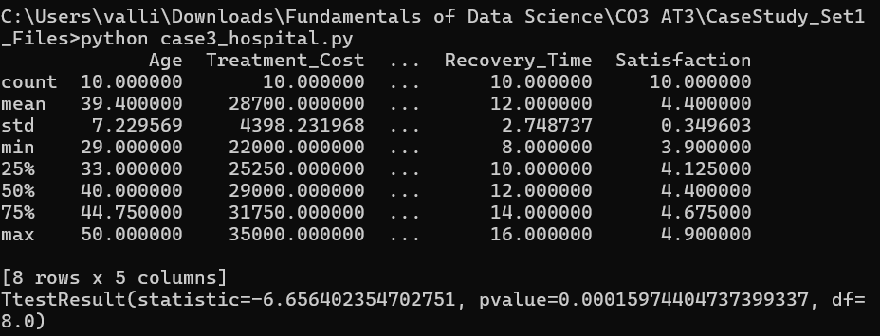

CASE STUDY 4 – Student Academic Performance Analysis
Problem Understanding
A university has collected student performance data, including attendance percentage, assignment marks, internal test scores, study hours, and final exam marks. The objective is to identify factors affecting student success, summarize academic performance using descriptive statistics, detect unusual performance patterns, and determine whether students with attendance above 75% perform significantly better than those with attendance below 75%.

Application of Data Science Concepts
This case study applies the following Data Science concepts:
- Descriptive Statistics: Summarizes attendance, assignment marks, internal test scores, study hours, and final exam marks.
- Distribution Analysis: Studies the distribution of student marks to identify overall performance trends.
- Outlier Detection: Identifies students with exceptionally high or low marks that may influence analysis.
- Statistical Inference: Uses hypothesis testing to determine whether attendance significantly affects academic performance.
These techniques help educational institutions improve teaching strategies and student performance.

Descriptive Statistics and Distribution Analysis
Descriptive statistics summarize student academic performance.
Mean
The mean represents the average student marks or attendance percentage.
Formula
$$\overline{x}=\frac{\sum{x}}{n}$$
A higher mean indicates better overall academic performance.

Median
The median is the middle value after arranging marks in ascending order.
The median is useful because it is less affected by extremely high or low scores.

Standard Deviation
Standard deviation measures the variation in student marks.
Formula
$$s=\sqrt{\frac{\sum{(}\left.x-\overline{x}{\left.)\right.}^{2}\right.}{n-1}}$$
- Small standard deviation → Students perform consistently.
- Large standard deviation → Student performance varies considerably.

Quartiles
Quartiles divide student marks into four equal groups.
- Q1 (25%)
- Q2 (Median)
- Q3 (75%)
Quartiles help evaluate score distribution and identify unusual performance.

Distribution Analysis
Student marks can be analyzed using:
- Histogram
- Density Plot
- Box Plot
Possible observations:
- Normal Distribution: Most students score around the average.
- Right-Skewed Distribution: A few students achieve exceptionally high marks.
- Left-Skewed Distribution: Many students score below average.
Distribution analysis helps instructors understand the overall academic performance of students.

Outlier Detection and Interpretation
Some students may have unusually high or low marks.
Possible reasons include:
- Exceptional academic performance.
- Poor attendance.
- Examination malpractice.
- Personal or medical issues.
- Data entry errors.
These values can influence statistical analysis.

Methods for Detecting Outliers
1. Box Plot
A box plot visually identifies students with unusually high or low marks.

2. Interquartile Range (IQR) Method
Formula
$$IQR=Q3-Q1$$
Lower Limit
$$Q1-1.5\left(IQR\right)$$
Upper Limit
$$Q3+1.5\left(IQR\right)$$
Values outside these limits are considered outliers.

3. Z-Score Method
Formula
$$Z=\frac{x-\overline{x}}{s}$$
If
$$∣Z∣>3$$
the observation is considered an outlier.

Interpretation
Before removing outliers,
- Verify student records.
- Check attendance records.
- Confirm examination results.
- Investigate exceptional academic achievements or special circumstances.
Outliers caused by genuine performance should remain in the dataset because they provide meaningful insights.

Statistical Inference (Hypothesis Testing)
The university wants to determine whether students with attendance above 75% score significantly higher than students with attendance below 75%.

Hypotheses
Null Hypothesis
$$H_{0}:μ_{Above75}=μ_{Below75}$$
There is no significant difference in final exam marks between the two groups.

Alternative Hypothesis
$$H_{1}:μ_{Above75}>μ_{Below75}$$
Students with attendance above 75% score significantly higher.

Testing Procedure
- Divide students into two groups:
  - Attendance above 75%
  - Attendance below 75%
- Calculate the mean final exam marks for both groups.
- Select the significance level (α = 0.05).
- Perform an Independent Sample t-test.
- Calculate the p-value.
- Compare the p-value with α.
Decision Rule
- If p < 0.05, reject the null hypothesis.
- If p ≥ 0.05, fail to reject the null hypothesis.

Analysis of Results
If the hypothesis test shows that students with attendance above 75% score significantly higher, the university can conclude that regular attendance positively influences academic performance.
If no significant difference is observed, additional factors such as study habits, assignment completion, or teaching methods should also be investigated.

Practical Recommendations
- Encourage students to maintain attendance above 75%.
- Provide academic support for students with low attendance.
- Monitor assignment completion and internal assessment performance.
- Conduct regular academic counseling sessions.
- Identify at-risk students early using learning analytics.
- Reward consistent attendance and academic improvement.

Conclusion
Descriptive statistics provide an overview of student academic performance, while outlier detection helps identify unusual performance patterns. Hypothesis testing determines whether attendance significantly affects final exam marks. These analyses help universities improve teaching strategies, increase student engagement, and enhance academic success.

Suggested Visualizations
- Histogram of Final Exam Marks
- Box Plot of Attendance Percentage
- Scatter Plot of Study Hours vs Final Marks
- Bar Chart comparing Above 75% vs Below 75% Attendance
- Pie Chart of Student Performance Categories

Python Code
import pandas as pd
import matplotlib.pyplot as plt
from scipy.stats import ttest_ind

# Load dataset
df = pd.read_csv("student_performance_data.csv")

# Descriptive Statistics
print(df.describe())

# Histogram
plt.hist(df["Final_Marks"], bins=10)
plt.title("Final Exam Marks Distribution")
plt.xlabel("Marks")
plt.ylabel("Frequency")
plt.show()

# Box Plot
plt.boxplot(df["Attendance"])
plt.title("Attendance Box Plot")
plt.show()

# Hypothesis Testing
above75 = df[df["Attendance"] > 75]["Final_Marks"]
below75 = df[df["Attendance"] <= 75]["Final_Marks"]

t_stat, p_value = ttest_ind(above75, below75)

print("T Statistic =", t_stat)
print("P Value =", p_value)

if p_value < 0.05:
print("Reject the Null Hypothesis")
print("Students with attendance above 75% score significantly higher.")
else:
print("Fail to Reject the Null Hypothesis")

Sample CSV Dataset
Student_ID | Attendance (%) | Assignment_Marks | Internal_Test | Study_Hours | Final_Marks
S001 | 92 | 88 | 85 | 5 | 90
S002 | 70 | 72 | 68 | 3 | 71
S003 | 85 | 81 | 80 | 4 | 84
S004 | 65 | 69 | 65 | 2 | 67
S005 | 95 | 90 | 92 | 6 | 94
S006 | 78 | 75 | 74 | 4 | 77
S007 | 60 | 62 | 60 | 2 | 64
S008 | 88 | 84 | 86 | 5 | 89
S009 | 73 | 71 | 69 | 3 | 72
S010 | 97 | 94 | 95 | 6 | 96

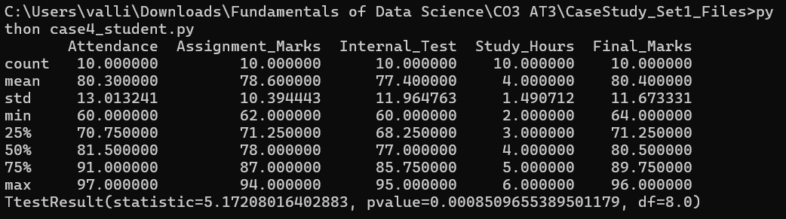

CASE STUDY 5 – Banking Loan Approval Analysis
Problem Understanding
A bank has collected customer loan application data, including income, credit score, loan amount, repayment history, employment status, and loan approval status. The bank wants to understand customer risk, identify unusual loan applications, and improve the loan approval process using statistical analysis.

Application of Data Science Concepts
This case study applies several Data Science concepts:
- Descriptive Statistics: Summarizes customer income, credit scores, and loan amounts.
- Distribution Analysis: Examines the distribution of financial variables to understand customer risk.
- Outlier Detection: Identifies unusually high loan amounts or extremely low credit scores.
- Statistical Inference: Uses hypothesis testing to determine whether customers with higher credit scores are more likely to receive loan approval.
These techniques help banks reduce financial risk and improve lending decisions.

Descriptive Statistics and Distribution Analysis
Descriptive statistics summarize customer financial information.
Mean
The mean represents the average income, credit score, or loan amount.
Formula
$$\overline{x}=\frac{\sum{x}}{n}$$
A higher average credit score generally indicates lower lending risk.

Median
The median is the middle value after arranging customer values in ascending order.
The median is useful because it is less affected by extremely high incomes or loan amounts.

Standard Deviation
Standard deviation measures the variation in customer income or credit scores.
Formula
$$s=\sqrt{\frac{\sum{(}\left.x-\overline{x}{\left.)\right.}^{2}\right.}{n-1}}$$
- Small standard deviation → Customers have similar financial characteristics.
- Large standard deviation → Customers vary widely in financial status.

Quartiles
Quartiles divide customer financial data into four equal groups.
- Q1 (25%)
- Q2 (Median)
- Q3 (75%)
Quartiles help identify customer segments and detect unusual financial values.

Distribution Analysis
The distribution of income, credit scores, and loan amounts can be analyzed using:
- Histogram
- Density Plot
- Box Plot
Possible observations:
- Normal Distribution: Most customers fall near the average income or credit score.
- Right-Skewed Distribution: A few customers have very high incomes or request large loans.
- Left-Skewed Distribution: Many customers have lower incomes or lower credit scores.
Understanding these distributions helps the bank classify customer risk.

Outlier Detection and Interpretation
Some loan applications may contain unusually high loan amounts or very low credit scores.
Possible causes include:
- High-value business loans.
- Fraudulent loan applications.
- Data entry errors.
- Customers with poor repayment history.
- Special financial assistance programs.
These values can influence loan approval analysis.

Methods for Detecting Outliers
1. Box Plot
A box plot visually identifies customers with unusually high loan amounts or very low credit scores.

2. Interquartile Range (IQR) Method
Formula
$$IQR=Q3-Q1$$
Lower Limit
$$Q1-1.5\left(IQR\right)$$
Upper Limit
$$Q3+1.5\left(IQR\right)$$
Values outside these limits are considered outliers.

3. Z-Score Method
Formula
$$Z=\frac{x-\overline{x}}{s}$$
If
$$∣Z∣>3$$
the observation is considered an outlier.

Interpretation
Before removing outliers,
- Verify customer documents.
- Check credit history.
- Confirm income proof.
- Investigate suspicious loan requests.
Genuine high-value business loans should remain in the analysis.

Statistical Inference (Hypothesis Testing)
The bank wants to determine whether customers with higher credit scores are more likely to receive loan approval.

Hypotheses
Null Hypothesis
$$H_{0}:μ_{approved}=μ_{rejected}$$
There is no significant difference in average credit scores between approved and rejected applicants.

Alternative Hypothesis
$$H_{1}:μ_{approved}>μ_{rejected}$$
Customers with higher credit scores are more likely to receive loan approval.

Testing Procedure
- Divide customers into two groups:
  - Approved
  - Rejected
- Calculate the average credit score for each group.
- Select the significance level (α = 0.05).
- Perform an Independent Sample t-test.
- Calculate the p-value.
- Compare the p-value with α.
Decision Rule
- If p < 0.05, reject the null hypothesis.
- If p ≥ 0.05, fail to reject the null hypothesis.

Analysis of Results
If the hypothesis test shows significantly higher credit scores among approved applicants, the bank can conclude that credit score is an important factor in loan approval decisions.
If no significant difference is found, other variables such as income, repayment history, or employment status should also be considered.

Practical Recommendations
- Use credit score as one of the primary loan approval criteria.
- Verify customer income and repayment history before approval.
- Monitor unusually large loan requests carefully.
- Implement fraud detection systems for suspicious applications.
- Periodically review lending policies using statistical analysis.
- Use predictive analytics to improve credit risk assessment.

Conclusion
Descriptive statistics summarize customer financial information, while outlier detection identifies unusual loan applications that may affect decision-making. Hypothesis testing provides statistical evidence on whether higher credit scores are associated with loan approval. These analyses help banks improve lending accuracy, reduce financial risk, and enhance customer evaluation.

Suggested Visualizations
- Histogram of Customer Income
- Box Plot of Loan Amount
- Scatter Plot of Income vs Credit Score
- Bar Chart of Approved vs Rejected Customers
- Pie Chart of Loan Approval Status

Python Code
import pandas as pd
import matplotlib.pyplot as plt
from scipy.stats import ttest_ind

# Load dataset
df = pd.read_csv("bank_loan_data.csv")

# Descriptive Statistics
print(df.describe())

# Histogram
plt.hist(df["Credit_Score"], bins=10)
plt.title("Credit Score Distribution")
plt.xlabel("Credit Score")
plt.ylabel("Frequency")
plt.show()

# Box Plot
plt.boxplot(df["Loan_Amount"])
plt.title("Loan Amount Box Plot")
plt.show()

# Hypothesis Testing
approved = df[df["Loan_Status"] == "Approved"]["Credit_Score"]
rejected = df[df["Loan_Status"] == "Rejected"]["Credit_Score"]

t_stat, p_value = ttest_ind(approved, rejected)

print("T Statistic =", t_stat)
print("P Value =", p_value)

if p_value < 0.05:
print("Reject the Null Hypothesis")
print("Higher credit scores significantly influence loan approval.")
else:
print("Fail to Reject the Null Hypothesis")

Sample CSV Dataset
Customer_ID | Income | Credit_Score | Loan_Amount | Repayment_History | Employment_Status | Loan_Status
C001 | 55000 | 780 | 250000 | Good | Salaried | Approved
C002 | 42000 | 650 | 180000 | Average | Self-Employed | Rejected
C003 | 70000 | 810 | 300000 | Good | Salaried | Approved
C004 | 38000 | 620 | 150000 | Poor | Unemployed | Rejected
C005 | 60000 | 790 | 280000 | Good | Salaried | Approved
C006 | 45000 | 670 | 200000 | Average | Self-Employed | Rejected
C007 | 75000 | 830 | 350000 | Excellent | Salaried | Approved
C008 | 40000 | 640 | 170000 | Poor | Contract | Rejected
C009 | 68000 | 800 | 320000 | Good | Salaried | Approved
C010 | 47000 | 690 | 210000 | Average | Self-Employed | Rejected

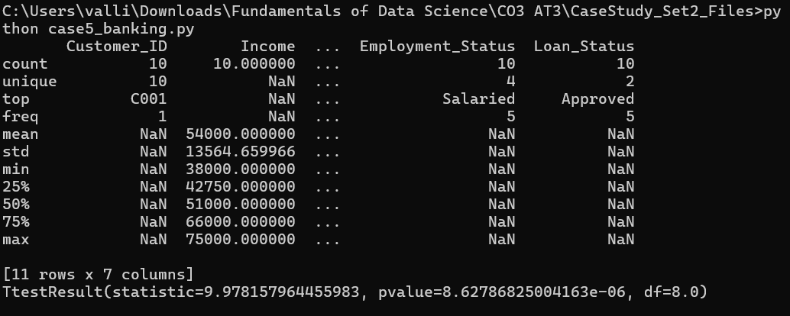

CASE STUDY 6 – Online Learning Platform Analysis
Problem Understanding
An online learning platform has collected learner activity data, including course completion percentage, quiz scores, video watch time, login frequency, and feedback ratings. The platform aims to improve learner engagement and academic success by analyzing learner behavior using descriptive statistics, outlier detection, and hypothesis testing.

Application of Data Science Concepts
This case study applies several Data Science concepts:
- Descriptive Statistics: Summarizes quiz scores, video watch time, login frequency, and course completion rates.
- Distribution Analysis: Studies learner activity patterns and performance distribution.
- Outlier Detection: Identifies unusually high or low learner activity.
- Statistical Inference: Uses hypothesis testing to determine whether learners who watch more than 70% of course videos score significantly higher in quizzes.
These analyses help improve learning quality and student engagement.

Descriptive Statistics and Distribution Analysis
Descriptive statistics summarize learner activity.
Mean
The mean represents the average quiz score, video watch time, or course completion percentage.
Formula
$$\overline{x}=\frac{\sum{x}}{n}$$
A higher mean indicates better learner engagement and performance.

Median
The median is the middle value after arranging learner scores in ascending order.
It is less affected by learners with exceptionally high or low activity.

Standard Deviation
Standard deviation measures the variation in learner performance.
Formula
$$s=\sqrt{\frac{\sum{(}\left.x-\overline{x}{\left.)\right.}^{2}\right.}{n-1}}$$
- Small standard deviation → Learners perform consistently.
- Large standard deviation → Learner performance varies significantly.

Quartiles
Quartiles divide learner activity into four equal groups.
- Q1 (25%)
- Q2 (Median)
- Q3 (75%)
Quartiles help identify learning patterns and unusual observations.

Distribution Analysis
The learner activity data can be analyzed using:
- Histogram
- Density Plot
- Box Plot
Possible observations:
- Normal Distribution: Most learners perform around the average.
- Right-Skewed Distribution: A few learners spend significantly more time watching videos.
- Left-Skewed Distribution: Many learners spend little time engaging with course materials.
Understanding the distribution helps instructors improve course delivery.

Outlier Detection and Interpretation
Some learners may have unusually high or low activity values.
Examples include:
- Watching every video multiple times.
- Very low login frequency.
- Extremely low quiz scores.
- Completing the course unusually quickly.
These observations may influence the analysis.

Methods for Detecting Outliers
1. Box Plot
A box plot visually identifies unusual learner activity.

2. Interquartile Range (IQR) Method
Formula
$$IQR=Q3-Q1$$
Lower Limit
$$Q1-1.5\left(IQR\right)$$
Upper Limit
$$Q3+1.5\left(IQR\right)$$
Values outside these limits are considered outliers.

3. Z-Score Method
Formula
$$Z=\frac{x-\overline{x}}{s}$$
If
$$∣Z∣>3$$
the observation is considered an outlier.

Interpretation
Before removing outliers,
- Verify learner activity logs.
- Check for technical issues.
- Confirm genuine learner behavior.
- Investigate possible misuse or automated activity.
Outliers representing genuine learning behavior should remain in the analysis.

Statistical Inference (Hypothesis Testing)
The platform wants to determine whether learners who watch more than 70% of course videos score significantly higher in quizzes than those who watch less.

Hypotheses
Null Hypothesis
$$H_{0}:μ_{>70\%}=μ_{≤70\%}$$
There is no significant difference in quiz scores.

Alternative Hypothesis
$$H_{1}:μ_{>70\%}>μ_{≤70\%}$$
Learners watching more than 70% of videos score significantly higher.

Testing Procedure
- Divide learners into two groups:
  - Video watch time > 70%
  - Video watch time ≤ 70%
- Calculate the mean quiz score for each group.
- Choose the significance level (α = 0.05).
- Perform an Independent Sample t-test.
- Calculate the p-value.
- Compare the p-value with α.
Decision Rule
- If p < 0.05, reject the null hypothesis.
- If p ≥ 0.05, fail to reject the null hypothesis.

Analysis of Results
If learners who watch more than 70% of the videos achieve significantly higher quiz scores, the platform can conclude that video engagement positively influences learning outcomes.
If no significant difference is observed, other factors such as login frequency, study habits, or assignment completion should also be considered.

Practical Recommendations
- Encourage learners to watch at least 70% of course videos.
- Send reminders to inactive learners.
- Recommend additional learning materials for low-performing students.
- Track learner progress using analytics dashboards.
- Provide personalized learning recommendations.
- Reward consistent learners with certificates or badges.

Conclusion
Descriptive statistics summarize learner engagement and performance, while outlier detection helps identify unusual learning behavior. Hypothesis testing determines whether watching more than 70% of course videos significantly improves quiz scores. These analyses support better learning strategies and improve student success.

Suggested Visualizations
- Histogram of Quiz Scores
- Box Plot of Video Watch Time
- Scatter Plot of Video Watch Time vs Quiz Score
- Bar Chart comparing Quiz Scores by Video Watch Percentage
- Pie Chart of Course Completion Status

Python Code
import pandas as pd
import matplotlib.pyplot as plt
from scipy.stats import ttest_ind

# Load dataset
df = pd.read_csv("online_learning_data.csv")

# Descriptive Statistics
print(df.describe())

# Histogram
plt.hist(df["Quiz_Score"], bins=10)
plt.title("Quiz Score Distribution")
plt.xlabel("Quiz Score")
plt.ylabel("Frequency")
plt.show()

# Box Plot
plt.boxplot(df["Video_Watch_Percentage"])
plt.title("Video Watch Percentage Box Plot")
plt.show()

# Hypothesis Testing
high_watch = df[df["Video_Watch_Percentage"] > 70]["Quiz_Score"]
low_watch = df[df["Video_Watch_Percentage"] <= 70]["Quiz_Score"]

t_stat, p_value = ttest_ind(high_watch, low_watch)

print("T Statistic =", t_stat)
print("P Value =", p_value)

if p_value < 0.05:
print("Reject the Null Hypothesis")
print("Watching more than 70% of videos significantly improves quiz scores.")
else:
print("Fail to Reject the Null Hypothesis")

Sample CSV Dataset
Learner_ID | Course_Completion (%) | Quiz_Score | Video_Watch_Percentage | Login_Frequency | Feedback_Rating
L001 | 95 | 92 | 90 | 30 | 4.8
L002 | 70 | 72 | 65 | 18 | 4.1
L003 | 88 | 85 | 82 | 25 | 4.5
L004 | 60 | 68 | 55 | 15 | 3.9
L005 | 98 | 95 | 96 | 35 | 5.0
L006 | 75 | 76 | 70 | 20 | 4.2
L007 | 55 | 60 | 45 | 12 | 3.8
L008 | 90 | 89 | 88 | 28 | 4.7
L009 | 68 | 71 | 60 | 17 | 4.0
L010 | 99 | 97 | 98 | 36 | 5.0

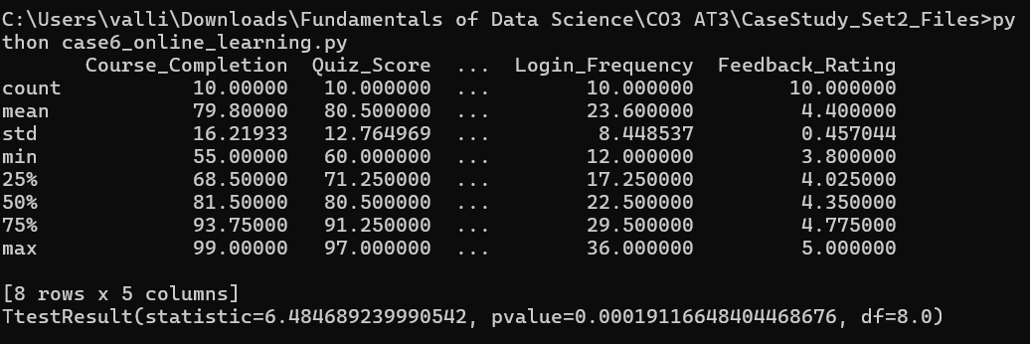

CASE STUDY 7 – Retail Sales Performance Analysis
Problem Understanding
A retail company has collected sales data from different stores, including daily sales, number of customers, discount percentage, product category, and profit. The company wants to analyze sales performance, identify unusual sales patterns, and determine whether offering higher discounts significantly increases sales revenue.

Application of Data Science Concepts
This case study applies the following Data Science concepts:
- Descriptive Statistics: Summarizes daily sales, customer count, discounts, and profit.
- Distribution Analysis: Examines the distribution of sales revenue across stores.
- Outlier Detection: Identifies unusually high or low sales days.
- Statistical Inference: Uses hypothesis testing to determine whether higher discounts significantly improve sales.
These analyses help businesses optimize pricing strategies and improve profitability.

Descriptive Statistics and Distribution Analysis
Descriptive statistics summarize retail sales performance.
Mean
The mean represents the average daily sales or average profit.
Formula
$$\overline{x}=\frac{\sum{x}}{n}$$
A higher mean indicates stronger overall sales performance.

Median
The median is the middle value after arranging daily sales in ascending order.
The median is useful because it is less affected by exceptionally high festival or holiday sales.

Standard Deviation
Standard deviation measures the variation in daily sales.
Formula
$$s=\sqrt{\frac{\sum{(}\left.x-\overline{x}{\left.)\right.}^{2}\right.}{n-1}}$$
- Small standard deviation → Stable sales performance.
- Large standard deviation → Significant variation in sales.

Quartiles
Quartiles divide the sales data into four equal parts.
- Q1 (25%)
- Q2 (Median)
- Q3 (75%)
Quartiles help identify sales trends and detect unusual observations.

Distribution Analysis
The sales distribution can be analyzed using:
- Histogram
- Density Plot
- Box Plot
Possible observations:
- Normal Distribution: Most sales values are close to the average.
- Right-Skewed Distribution: A few days have exceptionally high sales (festivals, promotions).
- Left-Skewed Distribution: Many days experience lower-than-average sales.
Distribution analysis helps managers understand customer purchasing behavior.

Outlier Detection and Interpretation
Some sales records may be unusually high or low.
Possible causes include:
- Festival season sales.
- Flash sales and promotional campaigns.
- Inventory shortages.
- Store closures.
- Data entry errors.
These observations may influence statistical analysis.

Methods for Detecting Outliers
1. Box Plot
A box plot visually identifies unusual daily sales values.

2. Interquartile Range (IQR) Method
Formula
$$IQR=Q3-Q1$$
Lower Limit
$$Q1-1.5\left(IQR\right)$$
Upper Limit
$$Q3+1.5\left(IQR\right)$$
Sales values outside these limits are considered outliers.

3. Z-Score Method
Formula
$$Z=\frac{x-\overline{x}}{s}$$
If
$$∣Z∣>3$$
the observation is considered an outlier.

Interpretation
Before removing outliers,
- Verify sales records.
- Check promotional campaign dates.
- Confirm inventory availability.
- Investigate billing errors.
Genuine high sales during promotions should remain in the analysis because they provide valuable business insights.

Statistical Inference (Hypothesis Testing)
The company wants to determine whether higher discounts significantly increase daily sales.

Hypotheses
Null Hypothesis
$$H_{0}:μ_{HighDiscount}=μ_{LowDiscount}$$
There is no significant difference in daily sales between high-discount and low-discount days.

Alternative Hypothesis
$$H_{1}:μ_{HighDiscount}>μ_{LowDiscount}$$
Higher discounts significantly increase daily sales.

Testing Procedure
- Divide sales records into two groups:
  - Discount > 20%
  - Discount ≤ 20%
- Calculate the average sales for each group.
- Choose the significance level (α = 0.05).
- Perform an Independent Sample t-test.
- Calculate the p-value.
- Compare the p-value with α.
Decision Rule
- If p < 0.05, reject the null hypothesis.
- If p ≥ 0.05, fail to reject the null hypothesis.

Analysis of Results
If the hypothesis test indicates significantly higher sales during high-discount periods, the company can conclude that discount strategies effectively increase customer purchases.
If no significant difference exists, other factors such as product quality, customer service, or marketing campaigns should also be evaluated.

Practical Recommendations
- Introduce seasonal promotional offers.
- Optimize discount percentages to maximize profit.
- Monitor inventory before running discount campaigns.
- Analyze customer buying behavior regularly.
- Use sales forecasting to improve inventory planning.
- Reward loyal customers with exclusive offers.

Conclusion
Descriptive statistics summarize retail sales performance, while outlier detection identifies unusual sales events. Hypothesis testing provides statistical evidence on whether higher discounts significantly increase sales. These analyses help retailers improve pricing strategies, maximize revenue, and enhance customer satisfaction.

Suggested Visualizations
- Histogram of Daily Sales
- Box Plot of Profit
- Scatter Plot of Discount Percentage vs Sales
- Bar Chart comparing High Discount vs Low Discount Sales
- Line Chart of Daily Sales Trend

Python Code
import pandas as pd
import matplotlib.pyplot as plt
from scipy.stats import ttest_ind

# Load dataset
df = pd.read_csv("retail_sales_data.csv")

# Descriptive Statistics
print(df.describe())

# Histogram
plt.hist(df["Daily_Sales"], bins=10)
plt.title("Daily Sales Distribution")
plt.xlabel("Daily Sales")
plt.ylabel("Frequency")
plt.show()

# Box Plot
plt.boxplot(df["Profit"])
plt.title("Profit Box Plot")
plt.show()

# Hypothesis Testing
high_discount = df[df["Discount_Percentage"] > 20]["Daily_Sales"]
low_discount = df[df["Discount_Percentage"] <= 20]["Daily_Sales"]

t_stat, p_value = ttest_ind(high_discount, low_discount)

print("T Statistic =", t_stat)
print("P Value =", p_value)

if p_value < 0.05:
print("Reject the Null Hypothesis")
print("Higher discounts significantly increase sales.")
else:
print("Fail to Reject the Null Hypothesis")

Sample CSV Dataset
Store_ID | Daily_Sales | Customers | Discount_Percentage | Product_Category | Profit
S001 | 45000 | 180 | 10 | Electronics | 9000
S002 | 52000 | 210 | 25 | Clothing | 9500
S003 | 48000 | 195 | 15 | Grocery | 8700
S004 | 61000 | 240 | 30 | Electronics | 11200
S005 | 55000 | 225 | 20 | Clothing | 10100
S006 | 47000 | 185 | 12 | Grocery | 8600
S007 | 64000 | 260 | 35 | Electronics | 11800
S008 | 50000 | 205 | 18 | Clothing | 9200
S009 | 59000 | 235 | 28 | Grocery | 10800
S010 | 46000 | 190 | 10 | Electronics | 8500

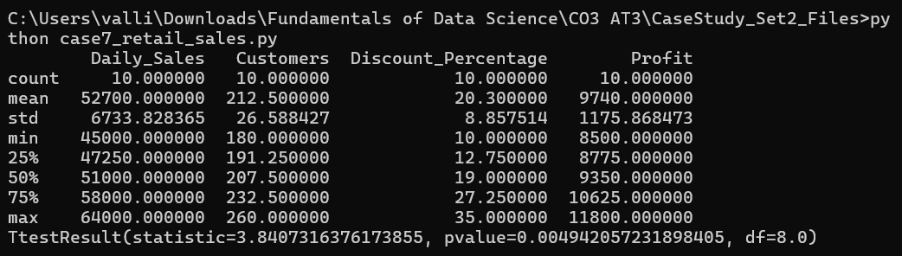

CASE STUDY 8 – Food Delivery Service Analysis
Problem Understanding
A food delivery company has collected order data, including delivery time, order value, delivery distance, customer rating, and delivery partner information. The company wants to evaluate delivery performance, identify unusual delivery patterns, and determine whether shorter delivery times lead to higher customer satisfaction.

Application of Data Science Concepts
This case study applies the following Data Science concepts:
- Descriptive Statistics: Summarizes delivery time, order value, delivery distance, and customer ratings.
- Distribution Analysis: Examines delivery performance across all orders.
- Outlier Detection: Identifies unusually long or short delivery times.
- Statistical Inference: Uses hypothesis testing to determine whether faster deliveries result in significantly higher customer ratings.
These analyses help improve delivery efficiency and customer satisfaction.

Descriptive Statistics and Distribution Analysis
Descriptive statistics summarize food delivery performance.
Mean
The mean represents the average delivery time, order value, or customer rating.
Formula
$$\overline{x}=\frac{\sum{x}}{n}$$
A lower average delivery time indicates better delivery performance.

Median
The median is the middle value after arranging delivery times in ascending order.
The median is useful because it is less affected by unusually delayed deliveries.

Standard Deviation
Standard deviation measures the variation in delivery times.
Formula
$$s=\sqrt{\frac{\sum{(}\left.x-\overline{x}{\left.)\right.}^{2}\right.}{n-1}}$$
- Small standard deviation → Delivery times are consistent.
- Large standard deviation → Delivery times vary significantly.

Quartiles
Quartiles divide delivery times into four equal groups.
- Q1 (25%)
- Q2 (Median)
- Q3 (75%)
Quartiles help identify delivery trends and unusual observations.

Distribution Analysis
The delivery time distribution can be analyzed using:
- Histogram
- Density Plot
- Box Plot
Possible observations:
- Normal Distribution: Most deliveries are completed within the expected time.
- Right-Skewed Distribution: A few deliveries take much longer because of traffic or weather.
- Left-Skewed Distribution: Most deliveries are completed very quickly.
Distribution analysis helps the company monitor delivery performance.

Outlier Detection and Interpretation
Some deliveries may have unusually high or low delivery times.
Possible causes include:
- Heavy traffic.
- Bad weather conditions.
- Restaurant preparation delays.
- Incorrect delivery address.
- Vehicle breakdown.
- Data entry errors.
These values can affect the overall analysis.

Methods for Detecting Outliers
1. Box Plot
A box plot visually identifies unusually long delivery times.

2. Interquartile Range (IQR) Method
Formula
$$IQR=Q3-Q1$$
Lower Limit
$$Q1-1.5\left(IQR\right)$$
Upper Limit
$$Q3+1.5\left(IQR\right)$$
Values outside these limits are considered outliers.

3. Z-Score Method
Formula
$$Z=\frac{x-\overline{x}}{s}$$
If
$$∣Z∣>3$$
the observation is considered an outlier.

Interpretation
Before removing outliers,
- Verify order details.
- Check traffic and weather reports.
- Confirm restaurant preparation time.
- Investigate delivery partner issues.
Outliers caused by genuine operational problems should remain in the dataset because they help identify areas for improvement.

Statistical Inference (Hypothesis Testing)
The company wants to determine whether faster deliveries result in higher customer ratings.

Hypotheses
Null Hypothesis
$$H_{0}:μ_{Fast}=μ_{Slow}$$
There is no significant difference in customer ratings between fast and slow deliveries.

Alternative Hypothesis
$$H_{1}:μ_{Fast}>μ_{Slow}$$
Fast deliveries receive significantly higher customer ratings.

Testing Procedure
- Divide deliveries into two groups:
  - Delivery Time ≤ 30 minutes
  - Delivery Time > 30 minutes
- Calculate the average customer rating for each group.
- Select the significance level (α = 0.05).
- Perform an Independent Sample t-test.
- Calculate the p-value.
- Compare the p-value with α.
Decision Rule
- If p < 0.05, reject the null hypothesis.
- If p ≥ 0.05, fail to reject the null hypothesis.

Analysis of Results
If the hypothesis test shows significantly higher customer ratings for faster deliveries, the company can conclude that reducing delivery time improves customer satisfaction.
If no significant difference is observed, factors such as food quality, packaging, and customer service should also be evaluated.

Practical Recommendations
- Optimize delivery routes using GPS.
- Reduce restaurant preparation time.
- Assign nearby delivery partners to new orders.
- Monitor traffic conditions in real time.
- Improve communication between restaurants and delivery partners.
- Collect customer feedback regularly to improve service quality.

Conclusion
Descriptive statistics summarize delivery performance, while outlier detection identifies unusual delivery times that require attention. Hypothesis testing determines whether faster deliveries significantly improve customer satisfaction. These analyses help food delivery companies improve operational efficiency and enhance customer experience.

Suggested Visualizations
- Histogram of Delivery Time
- Box Plot of Customer Ratings
- Scatter Plot of Delivery Time vs Customer Rating
- Bar Chart comparing Fast vs Slow Delivery Ratings
- Line Chart of Daily Average Delivery Time

Python Code
import pandas as pd
import matplotlib.pyplot as plt
from scipy.stats import ttest_ind

# Load dataset
df = pd.read_csv("food_delivery_data.csv")

# Descriptive Statistics
print(df.describe())

# Histogram
plt.hist(df["Delivery_Time"], bins=10)
plt.title("Delivery Time Distribution")
plt.xlabel("Delivery Time (Minutes)")
plt.ylabel("Frequency")
plt.show()

# Box Plot
plt.boxplot(df["Customer_Rating"])
plt.title("Customer Rating Box Plot")
plt.show()

# Hypothesis Testing
fast = df[df["Delivery_Time"] <= 30]["Customer_Rating"]
slow = df[df["Delivery_Time"] > 30]["Customer_Rating"]

t_stat, p_value = ttest_ind(fast, slow)

print("T Statistic =", t_stat)
print("P Value =", p_value)

if p_value < 0.05:
print("Reject the Null Hypothesis")
print("Fast deliveries significantly improve customer ratings.")
else:
print("Fail to Reject the Null Hypothesis")

Sample CSV Dataset
Order_ID | Delivery_Time (min) | Order_Value (₹) | Delivery_Distance (km) | Customer_Rating | Delivery_Partner
O001 | 25 | 450 | 3.2 | 4.9 | DP01
O002 | 38 | 620 | 6.5 | 4.1 | DP02
O003 | 28 | 510 | 4.0 | 4.8 | DP03
O004 | 42 | 700 | 7.2 | 3.9 | DP04
O005 | 22 | 390 | 2.8 | 5.0 | DP05
O006 | 35 | 580 | 5.6 | 4.2 | DP06
O007 | 27 | 475 | 3.5 | 4.8 | DP07
O008 | 45 | 760 | 8.0 | 3.8 | DP08
O009 | 30 | 540 | 4.5 | 4.7 | DP09
O010 | 24 | 420 | 3.0 | 4.9 | DP10

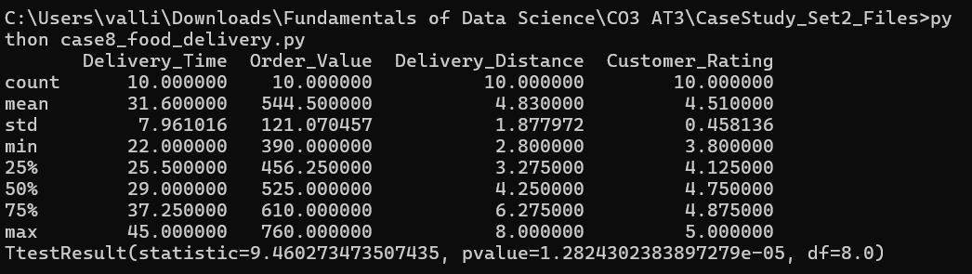
CASE STUDY 9 – Smart Agriculture Analysis
Problem Understanding
A smart agriculture system collects data from agricultural fields, including soil moisture, temperature, humidity, fertilizer usage, and crop yield. The objective is to evaluate crop production, identify abnormal environmental conditions, and determine whether maintaining optimal soil moisture significantly improves crop yield.

Application of Data Science Concepts
This case study applies the following Data Science concepts:
- Descriptive Statistics: Summarizes soil moisture, temperature, humidity, fertilizer usage, and crop yield.
- Distribution Analysis: Examines the distribution of crop yields across different fields.
- Outlier Detection: Identifies unusual environmental conditions or abnormal crop yields.
- Statistical Inference: Uses hypothesis testing to determine whether optimal soil moisture significantly improves crop yield.
These analyses support precision agriculture and improve farming productivity.

Descriptive Statistics and Distribution Analysis
Descriptive statistics summarize agricultural data.
Mean
The mean represents the average soil moisture, temperature, or crop yield.
Formula
$$\overline{x}=\frac{\sum{x}}{n}$$
A higher average crop yield indicates better agricultural productivity.

Median
The median is the middle value after arranging crop yield values in ascending order.
It is less affected by unusually high or low yields.

Standard Deviation
Standard deviation measures variation in crop yield.
Formula
$$s=\sqrt{\frac{\sum{(}\left.x-\overline{x}{\left.)\right.}^{2}\right.}{n-1}}$$
- Small standard deviation → Consistent crop production.
- Large standard deviation → Significant differences in yield across fields.

Quartiles
Quartiles divide crop yield data into four equal parts.
- Q1 (25%)
- Q2 (Median)
- Q3 (75%)
Quartiles help identify yield variation and support outlier detection.

Distribution Analysis
Crop yield can be analyzed using:
- Histogram
- Density Plot
- Box Plot
Possible observations:
- Normal Distribution: Most fields produce similar yields.
- Right-Skewed Distribution: A few fields produce exceptionally high yields.
- Left-Skewed Distribution: Many fields produce below-average yields.
Distribution analysis helps evaluate farming performance.

Outlier Detection and Interpretation
Unusual crop yields may occur because of:
- Pest attacks.
- Drought.
- Flooding.
- Excess fertilizer usage.
- Sensor failures.
- Data recording errors.

Methods for Detecting Outliers
1. Box Plot
Visual identification of unusually high or low crop yields.
2. Interquartile Range (IQR) Method
Formula
$$IQR=Q3-Q1$$
Lower Limit
$$Q1-1.5\left(IQR\right)$$
Upper Limit
$$Q3+1.5\left(IQR\right)$$
Values outside these limits are treated as outliers.
3. Z-Score Method
Formula
$$Z=\frac{x-\overline{x}}{s}$$
If
$$∣Z∣>3$$
the observation is considered an outlier.

Statistical Inference (Hypothesis Testing)
The objective is to determine whether maintaining optimal soil moisture significantly increases crop yield.
Hypotheses
Null Hypothesis
$$H_{0}:μ_{Optimal}=μ_{NonOptimal}$$
There is no significant difference in crop yield.
Alternative Hypothesis
$$H_{1}:μ_{Optimal}>μ_{NonOptimal}$$
Fields with optimal soil moisture produce significantly higher crop yields.

Testing Procedure
- Divide fields into:
  - Optimal soil moisture.
  - Non-optimal soil moisture.
- Calculate average crop yield.
- Use α = 0.05.
- Perform an Independent Sample t-test.
- Compare the p-value with α.
Decision Rule
- If p < 0.05, reject the null hypothesis.
- If p ≥ 0.05, fail to reject the null hypothesis.

Analysis of Results
If crop yields are significantly higher in fields with optimal soil moisture, farmers should prioritize irrigation management and continuous soil monitoring.

Practical Recommendations
- Install smart irrigation systems.
- Monitor soil moisture using IoT sensors.
- Apply fertilizers based on soil conditions.
- Analyze weather forecasts before irrigation.
- Use precision agriculture techniques.
- Monitor crop health regularly.

Conclusion
Descriptive statistics summarize agricultural performance, while outlier detection identifies abnormal environmental conditions. Hypothesis testing helps determine whether soil moisture significantly influences crop yield. These analyses support data-driven farming practices and improve agricultural productivity.

Suggested Visualizations
- Histogram of Crop Yield
- Box Plot of Soil Moisture
- Scatter Plot of Soil Moisture vs Crop Yield
- Bar Chart comparing Optimal vs Non-Optimal Fields
- Line Chart of Weekly Crop Yield

Python Code
import pandas as pd
import matplotlib.pyplot as plt
from scipy.stats import ttest_ind

df = pd.read_csv("smart_agriculture_data.csv")

print(df.describe())

plt.hist(df["Crop_Yield"], bins=10)
plt.title("Crop Yield Distribution")
plt.show()

plt.boxplot(df["Soil_Moisture"])
plt.title("Soil Moisture Box Plot")
plt.show()

optimal = df[df["Soil_Moisture"] >= 60]["Crop_Yield"]
non_optimal = df[df["Soil_Moisture"] < 60]["Crop_Yield"]

t_stat, p_value = ttest_ind(optimal, non_optimal)

print("T Statistic =", t_stat)
print("P Value =", p_value)

Sample CSV Dataset
Field_ID | Soil_Moisture (%) | Temperature (°C) | Humidity (%) | Fertilizer (kg) | Crop_Yield (kg)
F001 | 65 | 28 | 72 | 40 | 5200
F002 | 58 | 30 | 68 | 38 | 4700
F003 | 70 | 27 | 75 | 42 | 5500
F004 | 55 | 32 | 65 | 36 | 4500
F005 | 68 | 29 | 73 | 41 | 5400
F006 | 60 | 28 | 70 | 39 | 5000
F007 | 72 | 26 | 76 | 43 | 5600
F008 | 57 | 31 | 66 | 37 | 4600
F009 | 66 | 28 | 71 | 40 | 5300
F010 | 59 | 30 | 69 | 38 | 4800

CASE STUDY 10 – Airline Passenger Satisfaction Analysis
Problem Understanding
An airline company has collected passenger travel data, including flight delay, check-in time, baggage handling rating, in-flight service rating, and overall passenger satisfaction. The airline wants to evaluate service quality, identify unusual service patterns, and determine whether shorter flight delays significantly improve passenger satisfaction.

Application of Data Science Concepts
This case study applies the following Data Science concepts:
- Descriptive Statistics: Summarizes flight delays, check-in times, baggage handling ratings, and passenger satisfaction scores.
- Distribution Analysis: Examines the distribution of passenger satisfaction across flights.
- Outlier Detection: Identifies unusually long delays or exceptionally low satisfaction scores.
- Statistical Inference: Uses hypothesis testing to determine whether shorter flight delays significantly improve passenger satisfaction.
These analyses help airlines improve service quality and enhance the customer travel experience.

Descriptive Statistics and Distribution Analysis
Descriptive statistics summarize airline service performance.
Mean
The mean represents the average flight delay, check-in time, or passenger satisfaction score.
Formula
$$\overline{x}=\frac{\sum{x}}{n}$$
A lower average flight delay and a higher average satisfaction score indicate better airline performance.

Median
The median is the middle value after arranging the observations in ascending order.
The median is useful because it is less affected by unusually long flight delays.

Standard Deviation
Standard deviation measures the variation in flight delays or passenger satisfaction.
Formula
$$s=\sqrt{\frac{\sum{(}\left.x-\overline{x}{\left.)\right.}^{2}\right.}{n-1}}$$
- Small standard deviation → Consistent airline performance.
- Large standard deviation → Significant variation in service quality.

Quartiles
Quartiles divide the data into four equal groups.
- Q1 (25%)
- Q2 (Median)
- Q3 (75%)
Quartiles help understand the spread of service quality and support outlier detection.

Distribution Analysis
Passenger satisfaction can be analyzed using:
- Histogram
- Density Plot
- Box Plot
Possible observations:
- Normal Distribution: Most passengers report average satisfaction.
- Right-Skewed Distribution: Many passengers provide high satisfaction ratings.
- Left-Skewed Distribution: Many passengers report low satisfaction due to service issues.
Distribution analysis helps identify trends in customer experience.

Outlier Detection and Interpretation
Some flights may have unusually long delays or extremely low passenger satisfaction.
Possible causes include:
- Severe weather conditions.
- Technical aircraft issues.
- Airport congestion.
- Baggage handling delays.
- Data entry errors.
These observations can influence the statistical analysis.

Methods for Detecting Outliers
1. Box Plot
A box plot visually identifies unusually high flight delays or unusually low satisfaction scores.

2. Interquartile Range (IQR) Method
Formula
$$IQR=Q3-Q1$$
Lower Limit
$$Q1-1.5\left(IQR\right)$$
Upper Limit
$$Q3+1.5\left(IQR\right)$$
Values outside these limits are considered outliers.

3. Z-Score Method
Formula
$$Z=\frac{x-\overline{x}}{s}$$
If
$$∣Z∣>3$$
the observation is considered an outlier.

Statistical Inference (Hypothesis Testing)
The airline wants to determine whether shorter flight delays significantly improve passenger satisfaction.

Hypotheses
Null Hypothesis
$$H_{0}:μ_{ShortDelay}=μ_{LongDelay}$$
There is no significant difference in passenger satisfaction.

Alternative Hypothesis
$$H_{1}:μ_{ShortDelay}>μ_{LongDelay}$$
Passengers experiencing shorter flight delays have significantly higher satisfaction.

Testing Procedure
- Divide flights into two groups:
  - Flight Delay ≤ 30 minutes
  - Flight Delay > 30 minutes
- Calculate the average satisfaction score for each group.
- Choose the significance level (α = 0.05).
- Perform an Independent Sample t-test.
- Calculate the p-value.
- Compare the p-value with α.
Decision Rule
- If p < 0.05, reject the null hypothesis.
- If p ≥ 0.05, fail to reject the null hypothesis.

Analysis of Results
If the hypothesis test shows significantly higher satisfaction among passengers experiencing shorter delays, the airline can conclude that reducing delays improves customer satisfaction.
If no significant difference is observed, other factors such as in-flight service, baggage handling, or cabin comfort should also be investigated.

Practical Recommendations
- Minimize flight delays through better scheduling.
- Improve airport ground operations.
- Enhance baggage handling efficiency.
- Provide real-time updates to passengers during delays.
- Train staff to improve customer service.
- Regularly monitor passenger feedback to improve service quality.

Conclusion
Descriptive statistics summarize airline service quality, while outlier detection identifies unusual operational issues. Hypothesis testing provides statistical evidence on whether reducing flight delays improves passenger satisfaction. These analyses help airlines improve operational efficiency and enhance customer experience.

Suggested Visualizations
- Histogram of Flight Delays
- Box Plot of Passenger Satisfaction
- Scatter Plot of Flight Delay vs Passenger Satisfaction
- Bar Chart comparing Short Delay vs Long Delay Satisfaction
- Pie Chart of Passenger Satisfaction Levels

Python Code
import pandas as pd
import matplotlib.pyplot as plt
from scipy.stats import ttest_ind

# Load dataset
df = pd.read_csv("airline_passenger_data.csv")

# Descriptive Statistics
print(df.describe())

# Histogram
plt.hist(df["Flight_Delay"], bins=10)
plt.title("Flight Delay Distribution")
plt.xlabel("Flight Delay (Minutes)")
plt.ylabel("Frequency")
plt.show()

# Box Plot
plt.boxplot(df["Passenger_Satisfaction"])
plt.title("Passenger Satisfaction Box Plot")
plt.show()

# Hypothesis Testing
short_delay = df[df["Flight_Delay"] <= 30]["Passenger_Satisfaction"]
long_delay = df[df["Flight_Delay"] > 30]["Passenger_Satisfaction"]

t_stat, p_value = ttest_ind(short_delay, long_delay)

print("T Statistic =", t_stat)
print("P Value =", p_value)

if p_value < 0.05:
print("Reject the Null Hypothesis")
print("Shorter flight delays significantly improve passenger satisfaction.")
else:
print("Fail to Reject the Null Hypothesis")

Sample CSV Dataset
Passenger_ID | Flight_Delay (min) | Check_In_Time (min) | Baggage_Handling | In_Flight_Service | Passenger_Satisfaction
P001 | 15 | 12 | 5 | 5 | 4.9
P002 | 45 | 18 | 4 | 4 | 4.0
P003 | 20 | 10 | 5 | 5 | 4.8
P004 | 60 | 22 | 3 | 4 | 3.7
P005 | 10 | 9 | 5 | 5 | 5.0
P006 | 35 | 16 | 4 | 4 | 4.2
P007 | 18 | 11 | 5 | 5 | 4.9
P008 | 55 | 20 | 3 | 3 | 3.8
P009 | 25 | 13 | 4 | 5 | 4.7
P010 | 12 | 10 | 5 | 5 | 5.0

CASE STUDY 11: Public Transportation Usage Analysis
Problem Understanding
The city transport department has collected data on passenger count, ticket revenue, waiting time, travel duration, and route distance to evaluate the efficiency of the public transportation system. The primary objective is to identify service patterns, improve scheduling, reduce passenger waiting time, and enhance overall transport quality. The study requires descriptive statistics, outlier detection, and hypothesis testing to support data-driven decision-making.

Application of Data Science Concepts
Data Science techniques help transform raw transportation data into meaningful information.
The following concepts are applied:
- Descriptive Statistics to summarize passenger count, waiting time, and travel duration.
- Distribution Analysis to understand the spread and pattern of transportation data.
- Outlier Detection to identify abnormal waiting times or unusually high passenger counts.
- Hypothesis Testing to compare waiting times during peak and non-peak hours.
- Data Visualization using histograms, box plots, and scatter plots for better interpretation.

A. Descriptive Statistics and Distribution Analysis
The department should compute descriptive statistics for the following variables:
Passenger Count
Measures:
- Mean
- Median
- Mode
- Standard Deviation
- Minimum
- Maximum
- Quartiles (Q1, Q2, Q3)
Interpretation
- Mean passenger count indicates the average number of passengers using buses.
- Median reduces the influence of extreme values.
- Standard deviation shows how much passenger traffic varies across routes.
- Quartiles help identify heavily and lightly used routes.

Waiting Time
Measures:
- Mean Waiting Time
- Median Waiting Time
- Standard Deviation
- Quartiles
Interpretation
- Lower average waiting time indicates efficient scheduling.
- Higher standard deviation suggests inconsistent service.
- Quartiles help determine typical waiting times experienced by passengers.

Travel Duration
Measures:
- Mean
- Median
- Variance
- Standard Deviation
Interpretation
Travel duration analysis helps evaluate traffic congestion and route efficiency.

Distribution Analysis
Distribution analysis identifies whether the transportation data follows a normal distribution or exhibits skewness.
Possible distributions:
- Normal Distribution
- Right-Skewed Distribution
- Left-Skewed Distribution
For example:
- Passenger count may be right-skewed because peak-hour buses carry significantly more passengers.
- Waiting time may also be right-skewed due to occasional delays.
Suggested Visualizations
- Histogram
- Box Plot
- Density Plot
- Frequency Distribution Table

B. Outlier Detection and Interpretation
Outliers are observations that differ significantly from the rest of the dataset.
Examples include:
- Extremely high passenger counts during festivals.
- Long waiting times caused by traffic congestion or vehicle breakdowns.
These outliers can:
- Increase the mean waiting time.
- Distort standard deviation.
- Affect transportation planning.
- Produce misleading analytical results.

Methods for Detecting Outliers
1. Box Plot (IQR Method)
Calculate:
$$IQR=Q_{3}-Q_{1}$$
Lower Limit
$$Q_{1}-1.5\left(IQR\right)$$
Upper Limit
$$Q_{3}+1.5\left(IQR\right)$$
Values outside these limits are considered outliers.

2. Z-Score Method
Formula
$$Z=\frac{x-μ}{σ}$$
If
$$∣Z∣>3$$
the observation is considered an outlier.

Handling Outliers
- Verify whether the value is a recording error.
- Retain genuine peak-hour observations.
- Remove incorrect data entries.
- Apply data transformation if necessary.

C. Statistical Inference (Hypothesis Testing)
The objective is to determine whether average waiting time during peak hours is significantly higher than during non-peak hours.

Step 1: Formulate Hypotheses
Null Hypothesis
$$H_{0}:μ_{Peak}=μ_{NonPeak}$$
Average waiting times are equal.

Alternative Hypothesis
$$H_{1}:μ_{Peak}>μ_{NonPeak}$$
Average waiting time during peak hours is higher.

Step 2: Significance Level
$$α=0.05$$

Step 3: Select Statistical Test
A Two-Sample t-Test is appropriate because two independent groups (peak and non-peak hours) are compared.
Test Statistic:
$$t=\frac{{\overline{x}}_{1}-{\overline{x}}_{2}}{\sqrt{\frac{s_{1}^{2}}{n_{1}}+\frac{s_{2}^{2}}{n_{2}}}}$$

Step 4: Decision Rule
- If p-value < 0.05, reject the null hypothesis.
- Otherwise, fail to reject the null hypothesis.

Interpretation
If the null hypothesis is rejected:
- Peak-hour waiting time is significantly higher.
- Additional buses should be deployed.
- Scheduling should be optimized.
If not rejected:
- Waiting time differences are not statistically significant.

Analysis of Results
The transportation department can conclude that:
- Passenger count increases substantially during peak hours.
- Waiting time varies across routes.
- Outlier detection helps identify congestion events.
- Hypothesis testing provides statistical evidence for scheduling improvements.

Practical Recommendations
- Increase bus frequency during peak hours.
- Introduce smart scheduling based on passenger demand.
- Monitor waiting times using IoT sensors.
- Optimize high-demand routes.
- Deploy additional buses during festivals and special events.
- Continuously monitor passenger trends using real-time analytics.

Conclusion
Descriptive statistics provide a clear summary of transportation performance, while distribution analysis helps understand passenger flow patterns. Outlier detection identifies abnormal congestion events, and hypothesis testing determines whether waiting times differ significantly between peak and non-peak hours. These analyses support evidence-based decisions to improve transportation efficiency and passenger satisfaction.

Suggested Visualizations
- Histogram of Passenger Count
- Box Plot for Waiting Time
- Scatter Plot: Passenger Count vs Waiting Time
- • Bar Chart: Peak vs Non-Peak Average Waiting Time

Python Program
import pandas as pd
import matplotlib.pyplot as plt
data = {
"Passenger_Count": [120, 135, 150, 180, 210, 250, 190, 170, 160, 220],
"Waiting_Time": [5, 6, 7, 8, 10, 12, 9, 7, 6, 11],
"Travel_Duration": [25, 27, 28, 30, 35, 38, 32, 29, 27, 34]
}
df = pd.DataFrame(data)
print(df.describe())
df["Passenger_Count"].hist()
plt.title("Passenger Count Distribution")
plt.xlabel("Passenger Count")
plt.ylabel("Frequency")
plt.show()
plt.boxplot(df["Waiting_Time"])
plt.title("Waiting Time Box Plot")
plt.show()
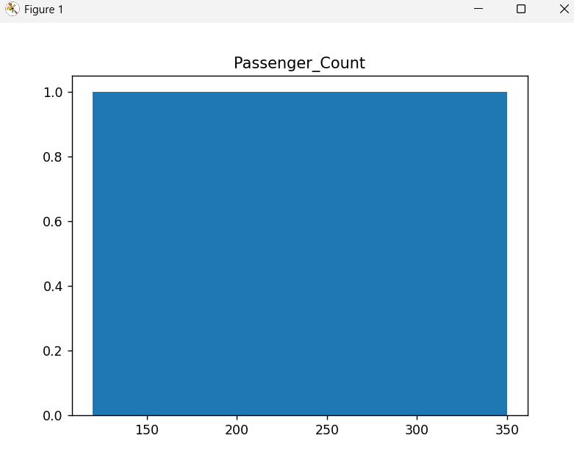
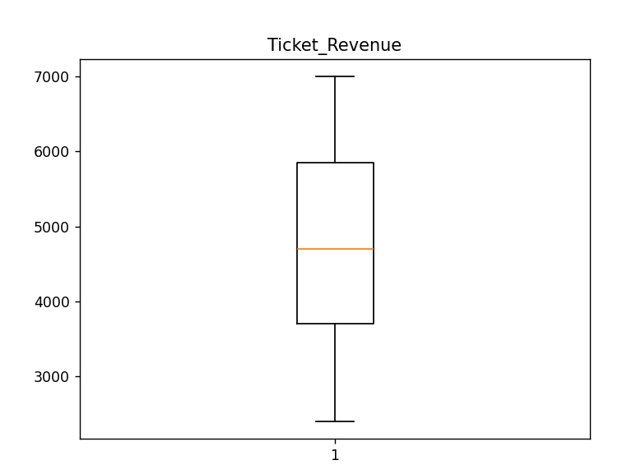
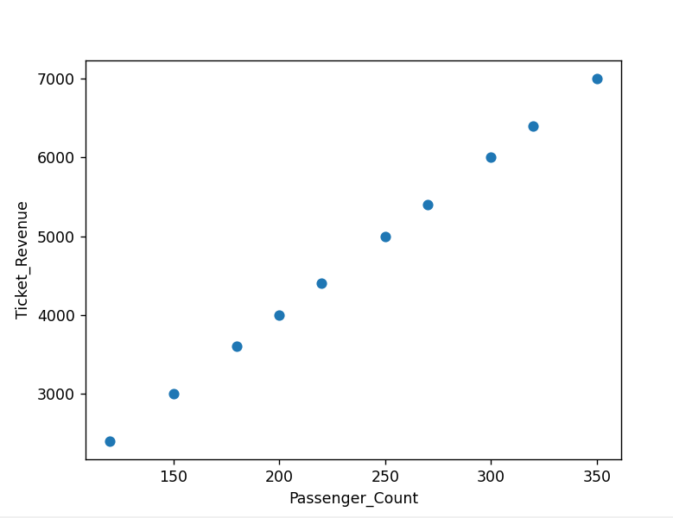
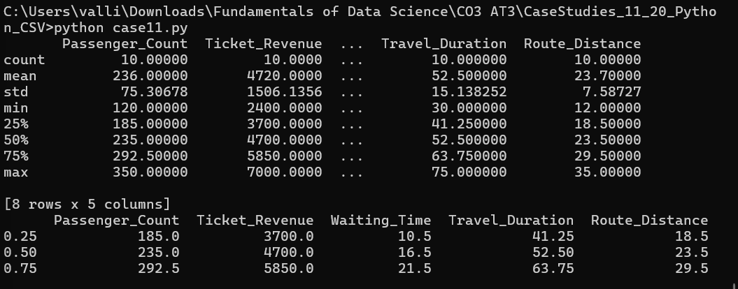
CASE STUDY 12: Agriculture Crop Yield Analysis
Problem Understanding
The Agriculture Department has collected data from different farms, including rainfall, fertilizer usage, soil moisture, temperature, and crop yield. The objective is to analyze the factors affecting crop productivity, identify abnormal crop yield values, and determine whether farms using organic fertilizer produce significantly different crop yields compared to farms using chemical fertilizer. This analysis will help improve agricultural planning and increase crop production.

Application of Data Science Concepts
Data Science techniques help analyze agricultural data and identify the key factors influencing crop production.
The following concepts are applied:
- Descriptive Statistics to summarize crop yield, rainfall, and fertilizer usage.
- Distribution Analysis to study the spread and pattern of crop production.
- Outlier Detection to identify abnormal crop yields caused by drought, pests, or excessive rainfall.
- Statistical Inference using confidence intervals and hypothesis testing to compare crop yields between organic and chemical fertilizer users.
- Data Visualization using histograms, box plots, and scatter plots for better understanding.

A. Descriptive Statistics and Distribution Analysis
Descriptive statistics summarize the agricultural dataset and provide an overview of crop productivity.
Crop Yield
The following statistical measures should be calculated:
- Mean
- Median
- Mode
- Standard Deviation
- Variance
- Minimum
- Maximum
- Quartiles (Q1, Q2, Q3)
Interpretation
- The mean crop yield represents the average production per farm.
- The median provides the middle crop yield and is less affected by extreme values.
- The standard deviation measures variation in crop production among farms.
- Quartiles divide the farms into four equal groups and help identify low- and high-performing farms.

Rainfall
Descriptive statistics for rainfall include:
- Mean Rainfall
- Median Rainfall
- Standard Deviation
- Quartiles
Interpretation
- Average rainfall helps evaluate weather conditions.
- Large variation in rainfall may indicate inconsistent climatic conditions affecting crop production.

Fertilizer Usage
Summary statistics include:
- Average fertilizer usage
- Standard deviation
- Quartiles
Interpretation
These statistics help determine whether fertilizer application is consistent across farms and how it may influence crop yield.

Distribution Analysis
Distribution analysis determines whether crop yield follows a normal distribution or exhibits skewness.
Possible distributions include:
- Normal Distribution
- Positively Skewed Distribution
- Negatively Skewed Distribution
For example:
- Crop yield may be left-skewed during drought years due to reduced production.
- Rainfall may be right-skewed if a few farms receive unusually high rainfall.
Suggested Visualizations
- Histogram of Crop Yield
- Box Plot for Rainfall
- Scatter Plot: Fertilizer Usage vs Crop Yield
- Density Plot

B. Outlier Detection and Interpretation
Outliers are observations that differ significantly from the rest of the data.
Examples include:
- Extremely low crop yields caused by drought.
- Crop damage due to pests or diseases.
- Excessively high crop yields due to unusually favorable weather conditions.
- Heavy rainfall leading to abnormal production values.
These outliers can:
- Distort the average crop yield.
- Increase the standard deviation.
- Produce misleading conclusions.
- Affect agricultural policy decisions.

Methods for Detecting Outliers
1. Interquartile Range (IQR) Method
Formula
$$IQR=Q_{3}-Q_{1}$$
Lower Limit
$$Q_{1}-1.5\left(IQR\right)$$
Upper Limit
$$Q_{3}+1.5\left(IQR\right)$$
Values outside these limits are considered outliers.

2. Z-Score Method
Formula
$$Z=\frac{x-μ}{σ}$$
If
$$∣Z∣>3$$
the observation is considered an outlier.

Handling Outliers
- Verify whether the observation is a data entry error.
- Retain genuine agricultural events such as drought or floods.
- Remove incorrect measurements.
- Apply transformation methods when necessary.

C. Statistical Inference
The department wants to determine whether farms using organic fertilizer produce significantly different crop yields compared with farms using chemical fertilizer.

Step 1: Formulate Hypotheses
Null Hypothesis (H₀)
$$H_{0}:μ_{Organic}=μ_{Chemical}$$
There is no significant difference in average crop yield between farms using organic fertilizer and farms using chemical fertilizer.

Alternative Hypothesis (H₁)
$$H_{1}:μ_{Organic}≠μ_{Chemical}$$
There is a significant difference in average crop yield between farms using organic fertilizer and chemical fertilizer.

Step 2: Significance Level
$$α=0.05$$

Step 3: Select Statistical Test
A Two-Sample t-Test is appropriate because crop yields from two independent groups (organic fertilizer users and chemical fertilizer users) are being compared.
Test Statistic:
$$t=\frac{{\overline{x}}_{1}-{\overline{x}}_{2}}{\sqrt{\frac{s_{1}^{2}}{n_{1}}+\frac{s_{2}^{2}}{n_{2}}}}$$

Step 4: Decision Rule
- If p-value < 0.05, reject the null hypothesis.
- Otherwise, fail to reject the null hypothesis.

Interpretation
If the null hypothesis is rejected:
- Fertilizer type significantly affects crop yield.
- The department can recommend the more effective fertilizer based on the analysis.
If the null hypothesis is not rejected:
- There is insufficient evidence to conclude that fertilizer type influences crop yield.

Analysis of Results
The agricultural department can conclude that:
- Descriptive statistics summarize crop production and rainfall patterns effectively.
- Distribution analysis identifies variations in crop productivity.
- Outlier detection highlights abnormal crop yields caused by environmental conditions.
- Hypothesis testing determines whether fertilizer type has a statistically significant effect on crop yield.

Practical Recommendations
- Encourage balanced fertilizer application based on soil testing.
- Monitor rainfall and soil moisture using smart agricultural sensors.
- Implement early pest detection systems.
- Train farmers in precision farming techniques.
- Promote sustainable irrigation practices.
- Use statistical monitoring to evaluate seasonal crop performance.

Conclusion
Descriptive statistics and distribution analysis provide valuable insights into crop yield, rainfall, and fertilizer usage. Outlier detection identifies abnormal agricultural events, while hypothesis testing helps determine whether organic fertilizer significantly affects crop productivity. These analyses support data-driven agricultural planning and improved farming practices.

Suggested Visualizations
- Histogram of Crop Yield
- Box Plot of Rainfall
- Scatter Plot: Fertilizer Usage vs Crop Yield
- Bar Chart: Organic vs Chemical Fertilizer Average Yield
Python Program
import pandas as pd
import matplotlib.pyplot as plt
data = {
"Crop_Yield": [32, 35, 30, 40, 38, 42, 36, 34, 39, 41],
"Rainfall": [110, 120, 95, 140, 135, 150, 125, 115, 138, 145],
"Fertilizer_Usage": [50, 55, 48, 60, 58, 62, 56, 52, 59, 61]
}
df = pd.DataFrame(data)
print(df.describe())
df["Crop_Yield"].hist()
plt.title("Crop Yield Distribution")
plt.xlabel("Crop Yield")
plt.ylabel("Frequency")
plt.show()
plt.boxplot(df["Rainfall"])
plt.title("Rainfall Box Plot")
plt.show()
plt.scatter(df["Fertilizer_Usage"], df["Crop_Yield"])
plt.xlabel("Fertilizer Usage")
plt.ylabel("Crop Yield")
plt.title("Fertilizer Usage vs Crop Yield")
plt.show()

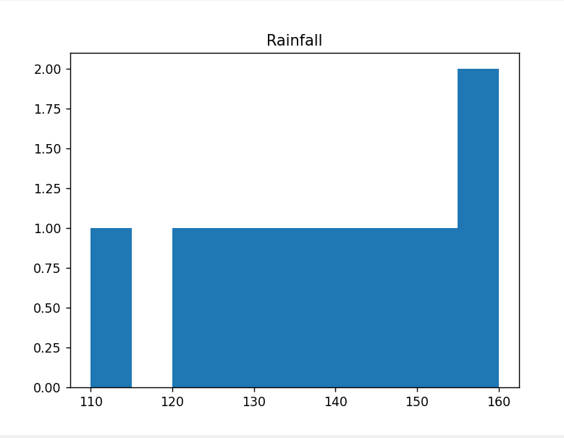
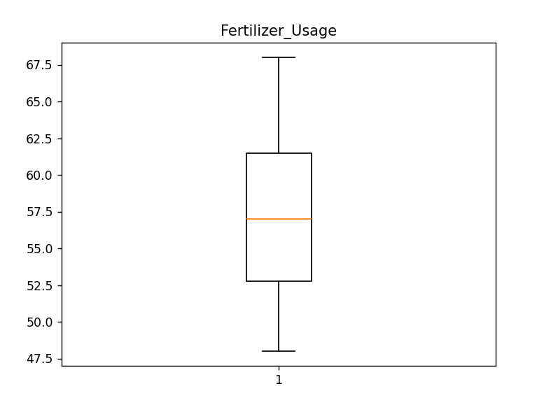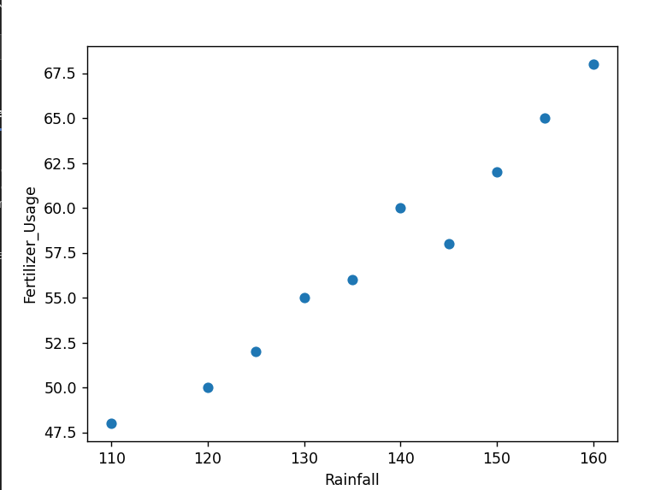

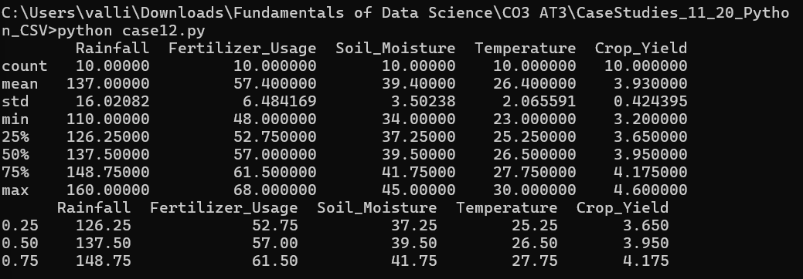

CASE STUDY 13 – Employee Productivity Analysis
Problem Understanding
A software company has collected employee productivity data, including working hours, number of completed tasks, project deadlines, experience level, and performance rating. The company aims to analyze employee productivity, improve workforce performance, and optimize project planning. The study requires the use of descriptive statistics, outlier detection, and hypothesis testing to identify performance trends and support evidence-based HR decisions.

Application of Data Science Concepts
Data Science techniques help transform employee performance data into meaningful insights for decision-making.
The following concepts are applied:
- Descriptive Statistics to summarize working hours, completed tasks, and performance ratings.
- Distribution Analysis to understand employee productivity patterns.
- Outlier Detection to identify unusually high or low task completion values.
- Statistical Inference to determine whether experienced employees complete significantly more tasks than newly joined employees.
- Data Visualization using histograms, box plots, and scatter plots to present employee performance clearly.

A. Descriptive Statistics and Distribution Analysis
The company should calculate descriptive statistics for the employee productivity dataset.
Working Hours
Statistical measures:
- Mean
- Median
- Standard Deviation
- Minimum
- Maximum
- Quartiles (Q1, Q2, Q3)
Interpretation
- The mean represents the average number of working hours.
- The median indicates the central working hour value.
- The standard deviation measures variation in employee working hours.
- Quartiles help classify employees into lower, middle, and higher working-hour groups.

Completed Tasks
Statistical measures include:
- Mean
- Median
- Mode
- Variance
- Standard Deviation
Interpretation
- The average number of completed tasks indicates overall productivity.
- A high standard deviation suggests inconsistent employee performance.
- The median provides a reliable measure when extreme task values exist.

Performance Rating
Statistical measures include:
- Mean
- Standard Deviation
- Quartiles
Interpretation
Performance ratings summarize employee efficiency and overall contribution to organizational goals.

Distribution Analysis
Distribution analysis determines how employee productivity is distributed.
Possible distributions include:
- Normal Distribution
- Positively Skewed Distribution
- Negatively Skewed Distribution
Examples:
- Completed tasks may be right-skewed because a few highly experienced employees complete significantly more tasks.
- Performance ratings may follow an approximately normal distribution if evaluation standards are consistent.
Suggested Visualizations
- Histogram of Completed Tasks
- Histogram of Performance Ratings
- Box Plot of Working Hours
- Scatter Plot: Experience vs Completed Tasks

B. Outlier Detection and Interpretation
Outliers are observations that differ substantially from the majority of employees.
Examples include:
- Employees completing an exceptionally high number of tasks.
- Employees completing unusually few tasks.
- Extremely long or short working hours.
These outliers may:
- Distort the average productivity.
- Increase standard deviation.
- Produce misleading conclusions regarding employee performance.
- Influence workforce planning decisions.

Methods for Detecting Outliers
1. Interquartile Range (IQR) Method
Formula
$$IQR=Q_{3}-Q_{1}$$
Lower Limit
$$Q_{1}-1.5\left(IQR\right)$$
Upper Limit
$$Q_{3}+1.5\left(IQR\right)$$
Values outside these limits are considered outliers.

2. Z-Score Method
Formula
$$Z=\frac{x-μ}{σ}$$
If
$$∣Z∣>3$$
the observation is treated as an outlier.

Handling Outliers
- Verify whether the value is due to a recording error.
- Retain genuine high-performing employees.
- Correct or remove incorrect records.
- Investigate the reasons behind unusually low productivity.

C. Statistical Inference
The company wants to determine whether experienced employees complete significantly more tasks than newly joined employees.

Step 1: Formulate Hypotheses
Null Hypothesis (H₀)
$$H_{0}:μ_{Experienced}=μ_{New}$$
There is no significant difference in the average number of completed tasks between experienced employees and newly joined employees.

Alternative Hypothesis (H₁)
$$H_{1}:μ_{Experienced}>μ_{New}$$
Experienced employees complete significantly more tasks than newly joined employees.

Step 2: Significance Level
$$α=0.05$$

Step 3: Select Statistical Test
A Two-Sample t-Test is appropriate because two independent groups (experienced and newly joined employees) are being compared.
Test Statistic
$$t=\frac{{\overline{x}}_{1}-{\overline{x}}_{2}}{\sqrt{\frac{s_{1}^{2}}{n_{1}}+\frac{s_{2}^{2}}{n_{2}}}}$$

Step 4: Decision Rule
- If p-value < 0.05, reject the null hypothesis.
- Otherwise, fail to reject the null hypothesis.

Interpretation
If the null hypothesis is rejected:
- Experienced employees complete significantly more tasks.
- Experience has a measurable effect on productivity.
- HR should implement mentoring programs and employee training.
If the null hypothesis is not rejected:
- There is insufficient statistical evidence that experience influences task completion.

Analysis of Results
The software company can conclude that:
- Descriptive statistics summarize employee productivity effectively.
- Distribution analysis identifies productivity patterns across employees.
- Outlier detection highlights exceptionally high or low performers.
- Hypothesis testing determines whether employee experience significantly affects task completion.

Practical Recommendations
- Provide continuous technical training for newly joined employees.
- Introduce mentorship programs led by experienced employees.
- Monitor productivity using performance dashboards.
- Balance workloads among employees.
- Reward consistently high-performing employees.
- Conduct periodic performance evaluations using statistical analysis.

Conclusion
Descriptive statistics provide a comprehensive summary of employee productivity, while distribution analysis helps identify productivity patterns across the workforce. Outlier detection identifies exceptional performers and employees requiring additional support. Hypothesis testing determines whether experienced employees complete significantly more tasks than newly joined employees, enabling data-driven human resource planning and performance improvement.

Suggested Visualizations
- Histogram of Completed Tasks
- Histogram of Performance Ratings
- Box Plot of Working Hours
- Scatter Plot: Experience Level vs Completed Tasks
- Bar Chart: Experienced vs Newly Joined Employees (Average Tasks Completed)
Python Programming
import pandas as pd
import matplotlib.pyplot as plt
data = {
"Working_Hours": [7, 8, 9, 8, 7, 9, 8, 8, 9, 7],
"Completed_Tasks": [12, 15, 18, 16, 11, 20, 17, 15, 19, 13],
"Performance_Rating": [3.8, 4.1, 4.5, 4.2, 3.7, 4.8, 4.4, 4.1, 4.6, 3.9]
}
df = pd.DataFrame(data)
print(df.describe())
df["Completed_Tasks"].hist()
plt.title("Completed Tasks Distribution")
plt.xlabel("Completed Tasks")
plt.ylabel("Frequency")
plt.show()
plt.boxplot(df["Working_Hours"])
plt.title("Working Hours Box Plot")
plt.show()
plt.scatter(df["Working_Hours"], df["Completed_Tasks"])
plt.title("Working Hours vs Completed Tasks")
plt.xlabel("Working Hours")
plt.ylabel("Completed Tasks")
plt.show()

Output:
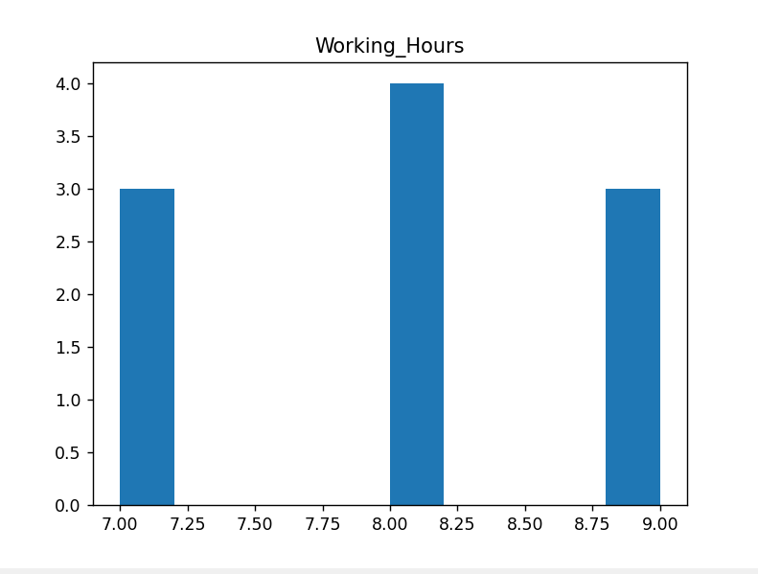

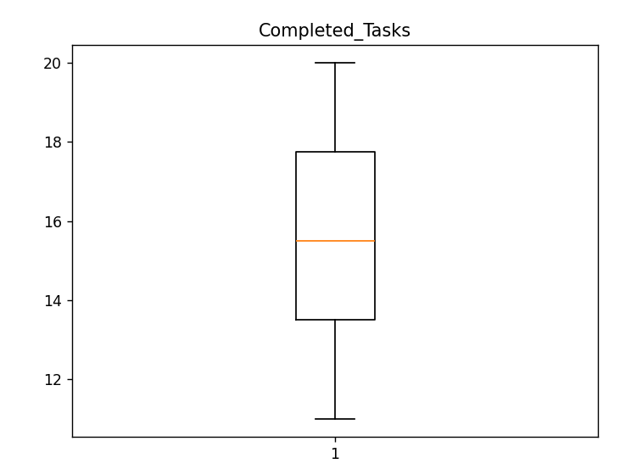
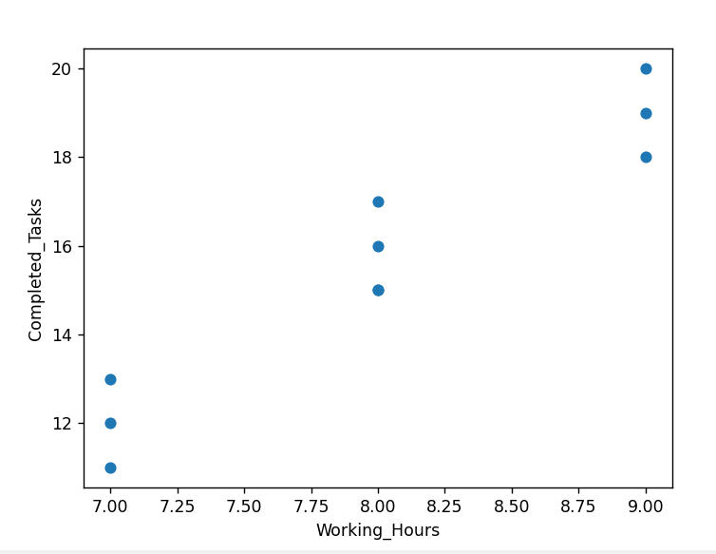
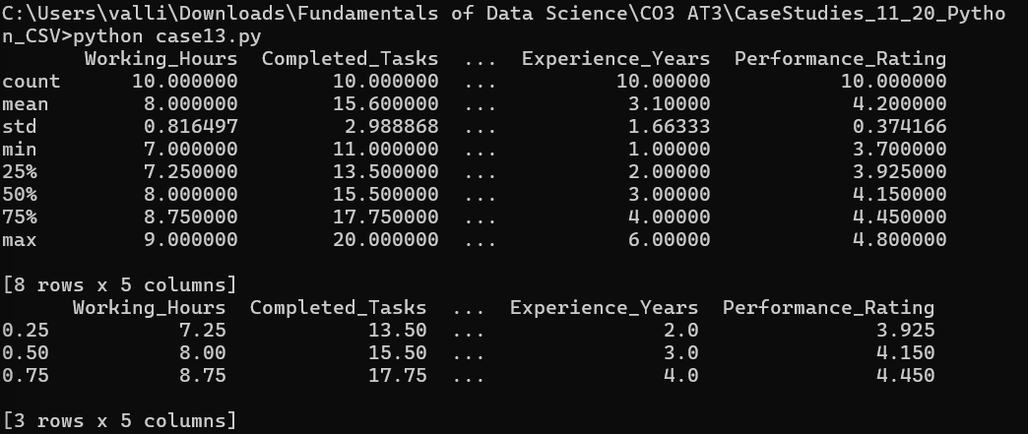

CASE STUDY 14 – Automobile Fuel Efficiency Analysis
Problem Understanding
An automobile company has collected vehicle performance data, including fuel consumption, engine capacity, vehicle weight, mileage, and maintenance cost. The company aims to analyze fuel efficiency, identify abnormal mileage values, and determine whether hybrid cars provide significantly better mileage than petrol cars. The analysis will support improvements in vehicle design, fuel economy, and customer satisfaction.

Application of Data Science Concepts
Data Science techniques enable engineers to analyze vehicle performance and identify factors affecting fuel efficiency.
The following concepts are applied:
- Descriptive Statistics to summarize mileage and fuel consumption.
- Distribution Analysis to understand the spread of fuel efficiency data.
- Outlier Detection to identify abnormal mileage values.
- Statistical Inference using confidence intervals and hypothesis testing to compare mileage between hybrid and petrol cars.
- Data Visualization using histograms, box plots, and scatter plots for better understanding.

A. Descriptive Statistics and Distribution Analysis
Descriptive statistics summarize the vehicle performance data and provide useful insights into mileage and fuel consumption.
Mileage
The following statistical measures should be calculated:
- Mean
- Median
- Mode
- Standard Deviation
- Variance
- Minimum
- Maximum
- Quartiles (Q1, Q2, Q3)
Interpretation
- The mean mileage represents the average distance travelled per litre of fuel.
- The median gives the central mileage value and reduces the influence of extreme observations.
- The standard deviation measures variation in mileage among different vehicles.
- Quartiles classify vehicles into low, medium, and high mileage groups.

Fuel Consumption
Statistical measures include:
- Mean Fuel Consumption
- Median
- Standard Deviation
- Variance
- Quartiles
Interpretation
- Average fuel consumption helps evaluate fuel efficiency.
- A high standard deviation indicates inconsistent vehicle performance.
- Quartiles identify vehicles with exceptionally high or low fuel consumption.

Distribution Analysis
Distribution analysis helps determine whether mileage follows a normal distribution or is skewed.
Possible distributions include:
- Normal Distribution
- Positively Skewed Distribution
- Negatively Skewed Distribution
For example:
- Mileage may be right-skewed because a few hybrid vehicles achieve exceptionally high fuel efficiency.
- Fuel consumption may be left-skewed if most vehicles consume similar amounts of fuel while only a few consume very little.
Suggested Visualizations
- Histogram of Mileage
- Histogram of Fuel Consumption
- Box Plot
- Scatter Plot: Engine Capacity vs Mileage

B. Outlier Detection and Interpretation
Outliers are observations that differ significantly from the rest of the vehicle dataset.
Examples include:
- Extremely high mileage values from hybrid or electric vehicles.
- Extremely low mileage caused by engine problems.
- Abnormally high fuel consumption due to poor maintenance.
- Incorrect data entry or measurement errors.
These outliers may:
- Distort the average mileage.
- Increase the standard deviation.
- Produce misleading conclusions regarding fuel efficiency.
- Affect vehicle design decisions.

Methods for Detecting Outliers
1. Interquartile Range (IQR) Method
Formula
$$IQR=Q_{3}-Q_{1}$$
Lower Limit
$$Q_{1}-1.5\left(IQR\right)$$
Upper Limit
$$Q_{3}+1.5\left(IQR\right)$$
Values outside these limits are considered outliers.

2. Z-Score Method
Formula
$$Z=\frac{x-μ}{σ}$$
If
$$∣Z∣>3$$
the observation is treated as an outlier.

Handling Outliers
- Verify whether the value is due to a recording error.
- Retain genuine high-performance hybrid vehicles.
- Correct or remove incorrect records.
- Perform separate analysis for hybrid and petrol vehicles if necessary.

C. Statistical Inference
The company wants to determine whether hybrid cars have significantly better mileage than petrol cars.

Step 1: Formulate Hypotheses
Null Hypothesis (H₀)
$$H_{0}:μ_{Hybrid}=μ_{Petrol}$$
There is no significant difference in average mileage between hybrid and petrol cars.

Alternative Hypothesis (H₁)
$$H_{1}:μ_{Hybrid}>μ_{Petrol}$$
Hybrid cars have significantly higher mileage than petrol cars.

Step 2: Confidence Level
Confidence Level
$$95\%$$
Significance Level
$$α=0.05$$

Step 3: Select Statistical Test
A Two-Sample t-Test is appropriate because the average mileage of two independent groups (hybrid and petrol cars) is being compared.
Test Statistic
$$t=\frac{{\overline{x}}_{1}-{\overline{x}}_{2}}{\sqrt{\frac{s_{1}^{2}}{n_{1}}+\frac{s_{2}^{2}}{n_{2}}}}$$

Step 4: Decision Rule
- If p-value < 0.05, reject the null hypothesis.
- Otherwise, fail to reject the null hypothesis.

Interpretation
If the null hypothesis is rejected:
- Hybrid cars provide significantly better mileage.
- The company should invest more in hybrid technology.
- Future vehicle development should prioritize fuel-efficient designs.
If the null hypothesis is not rejected:
- There is insufficient evidence that hybrid vehicles outperform petrol vehicles in mileage.

Analysis of Results
The automobile company can conclude that:
- Descriptive statistics summarize mileage and fuel consumption effectively.
- Distribution analysis identifies vehicle performance patterns.
- Outlier detection highlights vehicles with abnormal mileage.
- Hypothesis testing provides statistical evidence for comparing hybrid and petrol vehicle performance.

Practical Recommendations
- Increase investment in hybrid vehicle technology.
- Improve engine efficiency through advanced design.
- Perform routine maintenance to reduce fuel consumption.
- Monitor vehicle performance using onboard sensors.
- Encourage fuel-efficient driving practices.
- Continuously analyze mileage data to improve future vehicle models.

Conclusion
Descriptive statistics and distribution analysis provide valuable insights into vehicle mileage and fuel consumption. Outlier detection identifies abnormal vehicle performance, while hypothesis testing determines whether hybrid cars achieve significantly better mileage than petrol cars. These analyses support data-driven decisions for improving vehicle design, fuel efficiency, and environmental sustainability.

Suggested Visualizations
- Histogram of Mileage
- Histogram of Fuel Consumption
- Box Plot of Mileage
- Scatter Plot: Engine Capacity vs Mileage
- Bar Chart: Average Mileage of Hybrid vs Petrol Cars
Python Programming
import pandas as pd
import matplotlib.pyplot as plt
data = {
"Mileage": [18, 20, 22, 24, 26, 28, 30, 27, 25, 29],
"Fuel_Consumption": [6.8, 6.5, 6.2, 5.9, 5.7, 5.4, 5.1, 5.5, 5.8, 5.2],
"Engine_Capacity": [1200, 1300, 1400, 1500, 1600, 1700, 1800, 1600, 1500, 1750]
}
df = pd.DataFrame(data)
print(df.describe())
df["Mileage"].hist()
plt.title("Mileage Distribution")
plt.xlabel("Mileage (km/l)")
plt.ylabel("Frequency")
plt.show()
plt.boxplot(df["Mileage"])
plt.title("Mileage Box Plot")
plt.show()
plt.scatter(df["Engine_Capacity"], df["Mileage"])
plt.title("Engine Capacity vs Mileage")
plt.xlabel("Engine Capacity (cc)")
plt.ylabel("Mileage (km/l)")
plt.show()

Output:
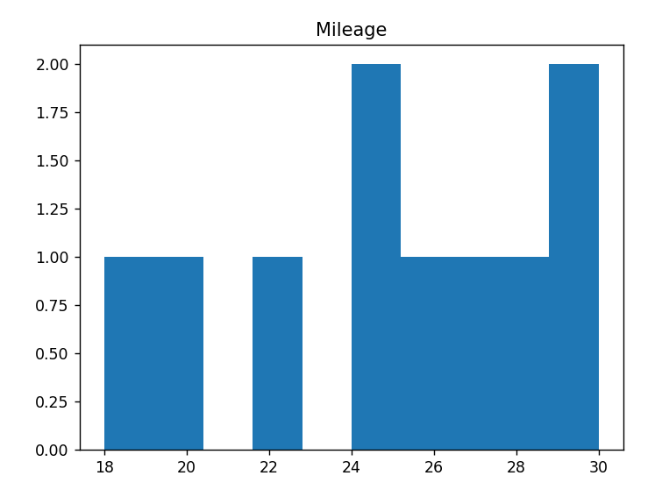

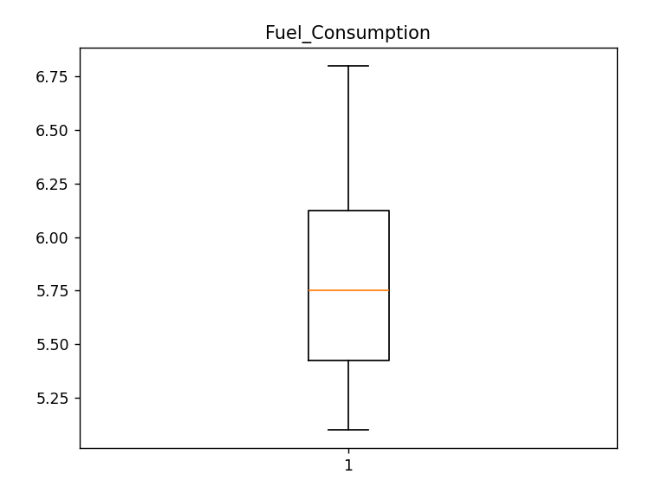

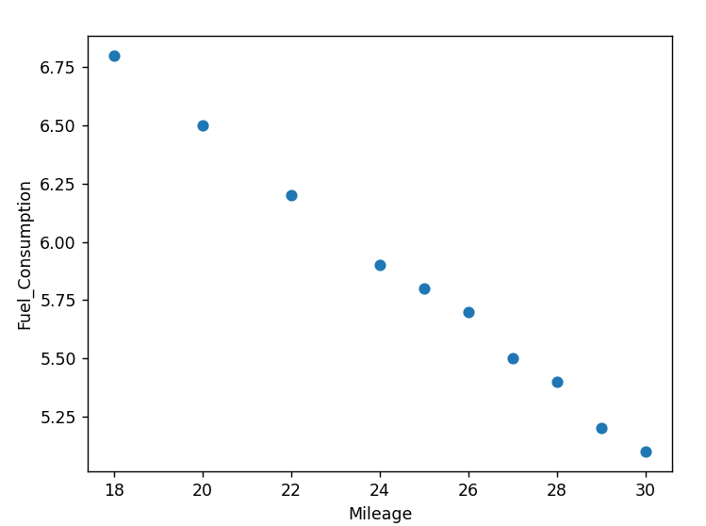

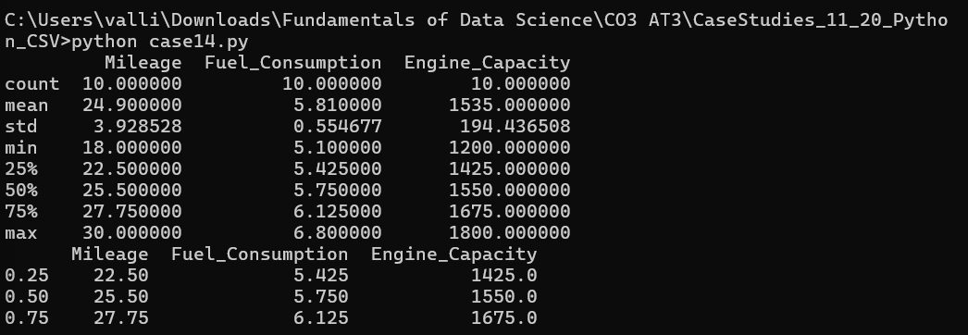

CASE STUDY 15 – Social Media Engagement Analysis
Problem Understanding
A digital marketing agency has collected social media engagement data, including number of likes, shares, comments, followers, posting time, and engagement rate. The agency wants to evaluate audience interaction, identify unusual engagement patterns, and determine whether video posts receive significantly higher engagement than image posts. The analysis helps improve content strategy, increase audience reach, and maximize campaign effectiveness.

Application of Data Science Concepts
Data Science techniques enable marketers to analyze user engagement and optimize social media content.
The following concepts are applied:
- Descriptive Statistics to summarize likes, shares, comments, and engagement rate.
- Distribution Analysis to study audience engagement patterns.
- Outlier Detection to identify viral posts with exceptionally high engagement.
- Statistical Inference using hypothesis testing to compare engagement between video posts and image posts.
- Data Visualization using histograms, box plots, and scatter plots.

A. Descriptive Statistics and Distribution Analysis
Descriptive statistics summarize the social media engagement data and help understand audience behavior.
Likes
Statistical measures include:
- Mean
- Median
- Mode
- Standard Deviation
- Variance
- Minimum
- Maximum
- Quartiles (Q1, Q2, Q3)
Interpretation
- The mean represents the average number of likes per post.
- The median provides the central tendency and is less affected by viral posts.
- The standard deviation measures the variability in likes across posts.
- Quartiles classify posts into low, medium, and highly liked categories.

Shares
Summary measures:
- Mean
- Median
- Standard Deviation
- Quartiles
Interpretation
Shares indicate how frequently content is redistributed by users and help measure audience reach.

Comments
Summary measures:
- Mean
- Median
- Standard Deviation
Interpretation
Comments reflect audience interaction and user interest in the content.

Engagement Rate
The engagement rate is calculated as:
$$\text{Engagement Rate}=\frac{\text{Likes + Shares + Comments}}{\text{Total Followers}}×100$$
Statistical measures:
- Mean Engagement Rate
- Standard Deviation
- Quartiles
Interpretation
- A higher engagement rate indicates stronger audience interaction.
- Consistent engagement across posts suggests an effective content strategy.

Distribution Analysis
Distribution analysis identifies the pattern of engagement across social media posts.
Possible distributions include:
- Normal Distribution
- Positively Skewed Distribution
- Negatively Skewed Distribution
Examples:
- Likes and shares are often positively skewed because a few viral posts receive exceptionally high engagement.
- Most posts receive moderate engagement, while only a small number become highly popular.
Suggested Visualizations
- Histogram of Likes
- Histogram of Engagement Rate
- Box Plot of Shares
- Scatter Plot: Followers vs Engagement Rate

B. Outlier Detection and Interpretation
Outliers are observations that differ significantly from the rest of the dataset.
Examples include:
- Viral posts receiving exceptionally high likes and shares.
- Sponsored campaigns generating unusually high engagement.
- Posts with extremely low engagement due to poor content quality or unsuitable posting times.
These outliers may:
- Increase the average engagement rate.
- Distort the standard deviation.
- Produce misleading conclusions about typical audience behavior.
- Affect marketing strategy decisions.

Methods for Detecting Outliers
1. Interquartile Range (IQR) Method
Formula
$$IQR=Q_{3}-Q_{1}$$
Lower Limit
$$Q_{1}-1.5\left(IQR\right)$$
Upper Limit
$$Q_{3}+1.5\left(IQR\right)$$
Values outside these limits are considered outliers.

2. Z-Score Method
Formula
$$Z=\frac{x-μ}{σ}$$
If
$$∣Z∣>3$$
the observation is considered an outlier.

Handling Outliers
- Verify whether the value represents genuine viral content.
- Retain authentic high-performing posts for marketing analysis.
- Remove incorrect or duplicate records.
- Analyze viral posts separately to understand successful content strategies.

C. Statistical Inference
The agency wants to determine whether video posts receive significantly higher engagement than image posts.

Step 1: Formulate Hypotheses
Null Hypothesis (H₀)
$$H_{0}:μ_{Video}=μ_{Image}$$
There is no significant difference in average engagement between video posts and image posts.

Alternative Hypothesis (H₁)
$$H_{1}:μ_{Video}>μ_{Image}$$
Video posts receive significantly higher engagement than image posts.

Step 2: Significance Level
$$α=0.05$$

Step 3: Select Statistical Test
A Two-Sample t-Test is appropriate because the average engagement of two independent groups (video posts and image posts) is being compared.
Test Statistic
$$t=\frac{{\overline{x}}_{1}-{\overline{x}}_{2}}{\sqrt{\frac{s_{1}^{2}}{n_{1}}+\frac{s_{2}^{2}}{n_{2}}}}$$

Step 4: Decision Rule
- If p-value < 0.05, reject the null hypothesis.
- Otherwise, fail to reject the null hypothesis.

Interpretation
If the null hypothesis is rejected:
- Video posts receive significantly higher engagement.
- The agency should prioritize video content in future campaigns.
- Marketing resources can be allocated toward high-performing content formats.
If the null hypothesis is not rejected:
- There is insufficient statistical evidence to conclude that video posts outperform image posts.

Analysis of Results
The digital marketing agency can conclude that:
- Descriptive statistics summarize audience engagement effectively.
- Distribution analysis identifies engagement trends across posts.
- Outlier detection highlights viral content and exceptional campaigns.
- Hypothesis testing provides statistical evidence for comparing engagement between video and image posts.

Practical Recommendations
- Increase the number of high-quality video posts.
- Analyze viral posts to identify successful content characteristics.
- Schedule posts during peak audience activity periods.
- Encourage audience interaction through polls and questions.
- Continuously monitor engagement metrics using social media analytics tools.
- Perform regular statistical analysis to evaluate campaign effectiveness.

Conclusion
Descriptive statistics and distribution analysis provide valuable insights into social media engagement patterns. Outlier detection identifies viral posts and abnormal engagement values, while hypothesis testing determines whether video posts achieve significantly higher engagement than image posts. These analyses support data-driven marketing strategies and improved audience engagement.

Suggested Visualizations
- Histogram of Likes
- Histogram of Engagement Rate
- Box Plot of Shares
- Scatter Plot: Followers vs Engagement Rate
- Bar Chart: Average Engagement of Video vs Image Posts

Python Program
import pandas as pd
import matplotlib.pyplot as plt
data = {
"Likes": [250, 320, 400, 520, 610, 700, 680, 590, 450, 720],
"Shares": [35, 42, 55, 70, 82, 95, 90, 78, 60, 98],
"Comments": [18, 25, 30, 40, 45, 52, 50, 43, 34, 55],
"Followers": [5000, 5200, 5400, 5600, 5800, 6000, 6200, 6400, 6600, 6800]
}

df = pd.DataFrame(data)
df["Engagement_Rate"] = (
(df["Likes"] + df["Shares"] + df["Comments"]) /
df["Followers"]
) * 100
print(df.describe())
df["Likes"].hist()
plt.title("Likes Distribution")
plt.xlabel("Likes")
plt.ylabel("Frequency")
plt.show()
plt.boxplot(df["Shares"])
plt.title("Shares Box Plot")
plt.show()
plt.scatter(df["Followers"], df["Engagement_Rate"])
plt.title("Followers vs Engagement Rate")
plt.xlabel("Followers")
plt.ylabel("Engagement Rate (%)")
plt.show()
Analysis of Results
- Average likes, shares, comments, and engagement rate provide a clear summary of audience interaction.
- Distribution analysis identifies whether engagement values are consistent or highly variable.
- Viral posts appear as outliers and should be analyzed separately to understand successful content characteristics.
- Statistical inference helps determine whether video posts generate significantly higher engagement than image posts, supporting evidence-based content strategy decisions.

Final Conclusion
The Social Media Engagement Analysis demonstrates that descriptive statistics effectively summarize audience interaction metrics such as likes, shares, comments, and engagement rate. Distribution analysis identifies engagement patterns, while outlier detection recognizes viral posts that may influence statistical results. Hypothesis testing enables the agency to determine whether video posts significantly outperform image posts in terms of engagement. These findings help optimize content strategy, improve audience reach, and maximize digital marketing performance.

Output:
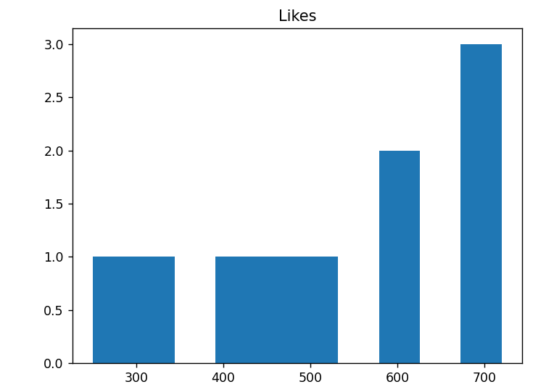

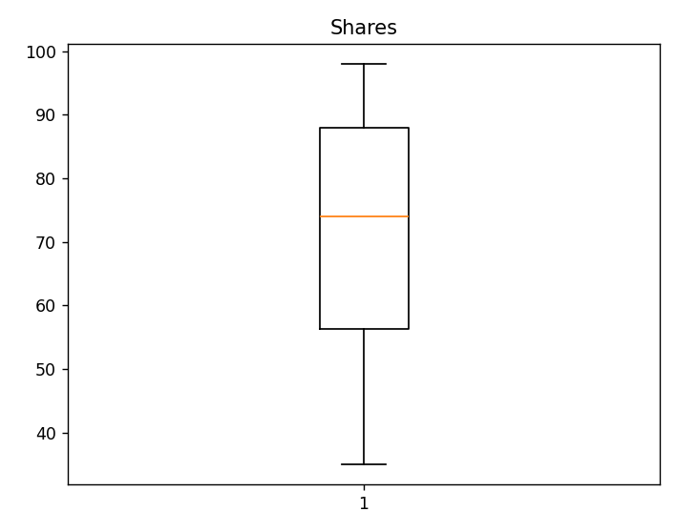

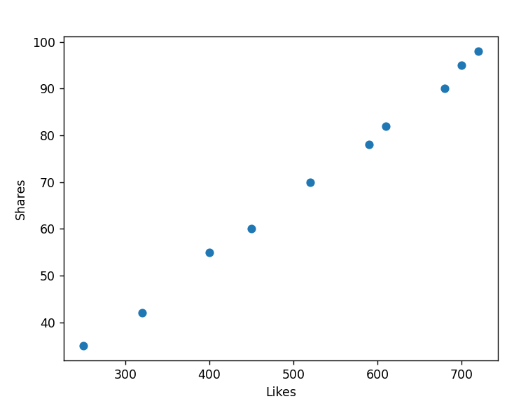
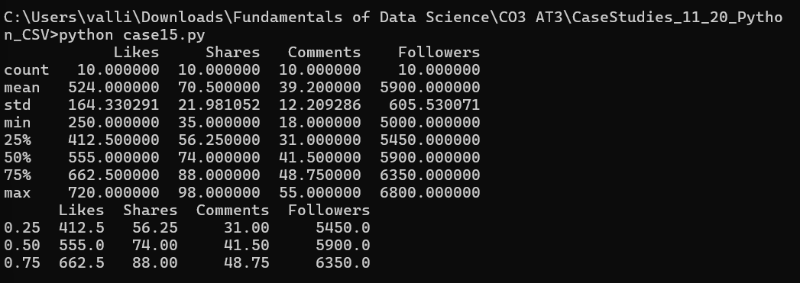
CASE STUDY 16 – Airline Passenger Satisfaction Analysis
Problem Understanding
An airline company has collected passenger feedback data, including ticket price, flight delay time, baggage waiting time, seat comfort rating, and overall satisfaction score. The airline aims to improve service quality by analyzing passenger satisfaction, identifying abnormal delay values, and determining whether passengers on on-time flights provide significantly higher satisfaction ratings than passengers on delayed flights. The results will help the airline improve operational efficiency and customer experience.

Application of Data Science Concepts
Data Science techniques help airlines analyze customer feedback and identify factors influencing passenger satisfaction.
The following concepts are applied:
- Descriptive Statistics to summarize delay time, baggage waiting time, and passenger satisfaction scores.
- Distribution Analysis to understand the pattern of service performance.
- Outlier Detection to identify unusually long delays or baggage waiting times.
- Statistical Inference using hypothesis testing to compare satisfaction ratings of passengers on on-time flights and delayed flights.
- Data Visualization using histograms, box plots, and scatter plots.

A. Descriptive Statistics and Distribution Analysis
Descriptive statistics summarize airline service quality and passenger satisfaction.
Flight Delay Time
The following statistical measures should be calculated:
- Mean
- Median
- Mode
- Standard Deviation
- Variance
- Minimum
- Maximum
- Quartiles (Q1, Q2, Q3)
Interpretation
- The mean delay time represents the average flight delay.
- The median provides the typical delay while reducing the influence of extreme values.
- The standard deviation measures variability in delays.
- Quartiles divide flights into different delay categories.

Baggage Waiting Time
Summary measures include:
- Mean
- Median
- Standard Deviation
- Quartiles
Interpretation
- Average baggage waiting time indicates airport service efficiency.
- A higher standard deviation suggests inconsistent baggage handling.

Passenger Satisfaction Score
Summary measures include:
- Mean
- Median
- Standard Deviation
- Quartiles
Interpretation
- Higher average satisfaction scores indicate better passenger experience.
- Quartiles help classify passengers into different satisfaction levels.

Distribution Analysis
Distribution analysis determines whether passenger satisfaction and service variables follow a normal distribution.
Possible distributions include:
- Normal Distribution
- Positively Skewed Distribution
- Negatively Skewed Distribution
Examples:
- Flight delay times are often positively skewed because most flights experience short delays while a few flights have very long delays.
- Passenger satisfaction scores may be negatively skewed if most passengers provide high ratings.
Suggested Visualizations
- Histogram of Flight Delay Time
- Histogram of Passenger Satisfaction Score
- Box Plot of Baggage Waiting Time
- Scatter Plot: Flight Delay vs Satisfaction Score

B. Outlier Detection and Interpretation
Outliers are observations that differ significantly from the rest of the dataset.
Examples include:
- Extremely long flight delays caused by severe weather or technical failures.
- Very long baggage waiting times.
- Extremely low passenger satisfaction scores.
These outliers may:
- Increase the average delay time.
- Distort passenger satisfaction analysis.
- Produce misleading conclusions regarding airline service quality.
- Affect future operational planning.

Methods for Detecting Outliers
1. Interquartile Range (IQR) Method
Formula
$$IQR=Q_{3}-Q_{1}$$
Lower Limit
$$Q_{1}-1.5\left(IQR\right)$$
Upper Limit
$$Q_{3}+1.5\left(IQR\right)$$
Values outside these limits are considered outliers.

2. Z-Score Method
Formula
$$Z=\frac{x-μ}{σ}$$
If
$$∣Z∣>3$$
the observation is considered an outlier.

Handling Outliers
- Verify whether the delay is genuine or due to data entry errors.
- Retain genuine operational events such as weather-related delays.
- Remove incorrect records.
- Analyze severe delays separately to improve operational planning.

C. Statistical Inference
The airline wants to determine whether passengers on on-time flights provide significantly higher satisfaction ratings than passengers on delayed flights.

Step 1: Formulate Hypotheses
Null Hypothesis (H₀)
$$H_{0}:μ_{OnTime}=μ_{Delayed}$$
There is no significant difference in passenger satisfaction between on-time and delayed flights.

Alternative Hypothesis (H₁)
$$H_{1}:μ_{OnTime}>μ_{Delayed}$$
Passengers on on-time flights have significantly higher satisfaction scores than passengers on delayed flights.

Step 2: Significance Level
$$α=0.05$$

Step 3: Select Statistical Test
A Two-Sample t-Test is appropriate because satisfaction scores of two independent groups (on-time flights and delayed flights) are being compared.
Test Statistic
$$t=\frac{{\overline{x}}_{1}-{\overline{x}}_{2}}{\sqrt{\frac{s_{1}^{2}}{n_{1}}+\frac{s_{2}^{2}}{n_{2}}}}$$

Step 4: Decision Rule
- If p-value < 0.05, reject the null hypothesis.
- If p-value ≥ 0.05, fail to reject the null hypothesis.

Interpretation
If the null hypothesis is rejected:
- On-time flights significantly improve passenger satisfaction.
- Reducing delays should become a major operational objective.
- Service quality initiatives can focus on punctuality.
If the null hypothesis is not rejected:
- There is insufficient statistical evidence that flight punctuality significantly affects passenger satisfaction.

Analysis of Results
The airline company can conclude that:
- Descriptive statistics effectively summarize delay times, baggage waiting times, and satisfaction scores.
- Distribution analysis identifies service performance patterns.
- Outlier detection highlights unusual operational issues.
- Hypothesis testing provides statistical evidence regarding the impact of flight punctuality on passenger satisfaction.

Practical Recommendations
- Improve flight scheduling to reduce delays.
- Enhance baggage handling efficiency.
- Provide real-time delay notifications to passengers.
- Increase customer support during flight disruptions.
- Monitor passenger satisfaction regularly using statistical analysis.
- Introduce predictive maintenance to reduce technical delays.

Conclusion
Descriptive statistics and distribution analysis provide valuable insights into airline service quality and passenger satisfaction. Outlier detection identifies abnormal delays and baggage handling issues, while hypothesis testing determines whether on-time flights significantly improve passenger satisfaction. These analyses support data-driven decisions for improving operational efficiency and customer experience.

Suggested Visualizations
- Histogram of Flight Delay Time
- Histogram of Passenger Satisfaction Scores
- Box Plot of Baggage Waiting Time
- Scatter Plot: Flight Delay vs Satisfaction Score
- Bar Chart: Average Satisfaction (On-Time vs Delayed Flights)
Python Program
import pandas as pd
import matplotlib.pyplot as plt
data = {
"Flight_Delay": [5, 10, 0, 15, 20, 35, 45, 8, 12, 3],
"Baggage_Waiting": [10, 12, 8, 15, 18, 25, 30, 11, 13, 9],
"Satisfaction_Score": [4.8, 4.6, 5.0, 4.4, 4.2, 3.8, 3.5, 4.7, 4.5, 4.9]
}
df = pd.DataFrame(data)
print(df.describe())
df["Flight_Delay"].hist()
plt.title("Flight Delay Distribution")
plt.xlabel("Delay Time (minutes)")
plt.ylabel("Frequency")
plt.show()
plt.boxplot(df["Baggage_Waiting"])
plt.title("Baggage Waiting Time")
plt.show()
plt.scatter(df["Flight_Delay"], df["Satisfaction_Score"])
plt.title("Flight Delay vs Passenger Satisfaction")
plt.xlabel("Flight Delay (minutes)")
plt.ylabel("Satisfaction Score")
plt.show()
Analysis of Results
- Average flight delay and baggage waiting time provide an overview of operational efficiency.
- Passenger satisfaction scores indicate the overall service quality.
- Distribution analysis identifies whether delays are consistent or highly variable.
- Outlier detection highlights severe delays that require operational attention.
- Hypothesis testing helps determine whether flight punctuality significantly influences passenger satisfaction.

Final Conclusion
The Airline Passenger Satisfaction Analysis demonstrates that descriptive statistics effectively summarize delay time, baggage waiting time, and satisfaction scores. Distribution analysis reveals patterns in airline service performance, while outlier detection identifies abnormal operational events such as severe flight delays. Hypothesis testing enables the airline to determine whether passengers on on-time flights provide significantly higher satisfaction ratings than passengers on delayed flights. These findings support evidence-based improvements in airline operations and customer service.

Output:
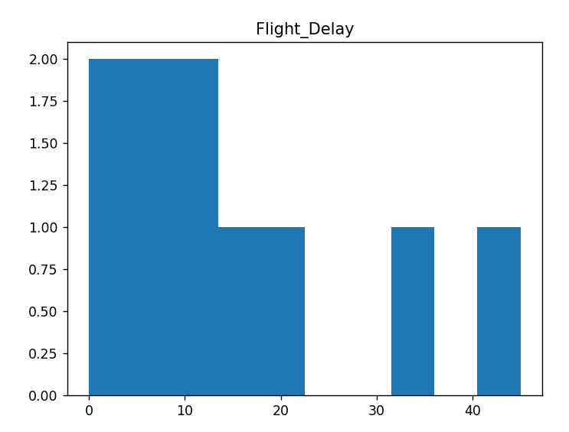
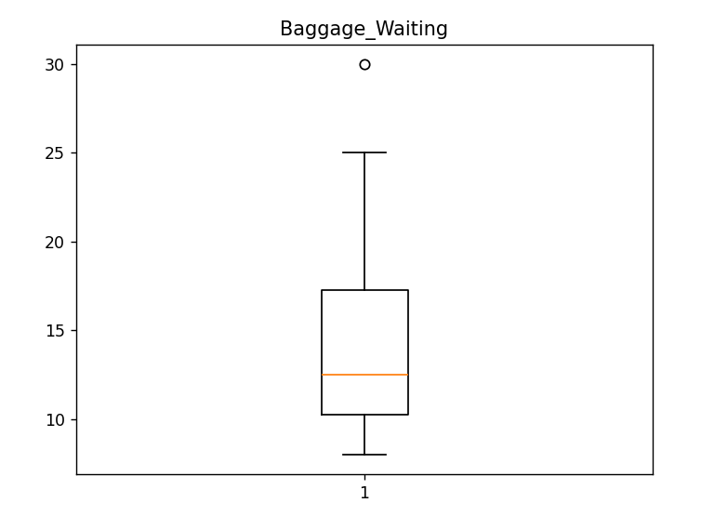

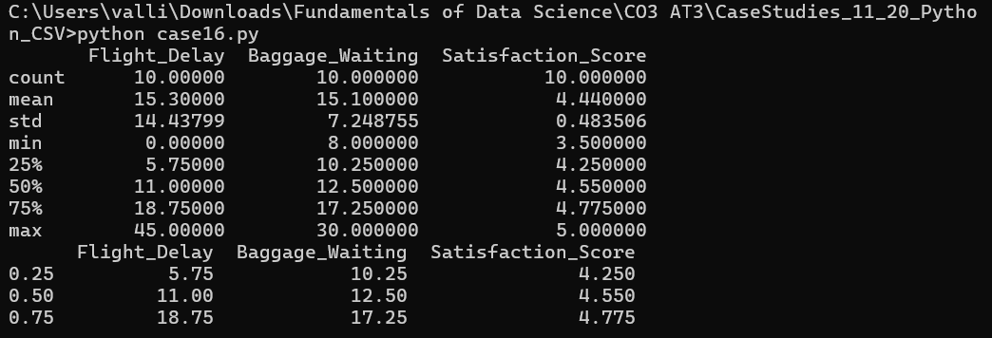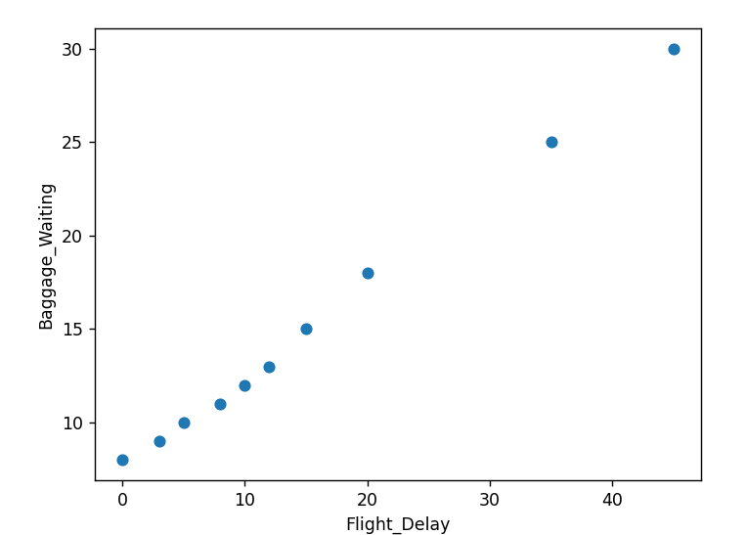

CASE STUDY 17 – Smart City Traffic Analysis
Problem Understanding
A smart city traffic department has collected traffic data, including vehicle count, average speed, signal waiting time, accident count, and pollution level from different roads. The objective is to analyze traffic patterns, reduce congestion, improve road safety, and optimize traffic signal management. The study requires descriptive statistics, outlier detection, and hypothesis testing to support evidence-based traffic management decisions.

Application of Data Science Concepts
Data Science techniques help traffic authorities transform raw traffic data into meaningful insights for urban planning.
The following concepts are applied:
- Descriptive Statistics to summarize vehicle count, waiting time, and average speed.
- Distribution Analysis to study traffic flow patterns.
- Outlier Detection to identify abnormal traffic conditions caused by accidents, festivals, or roadblocks.
- Statistical Inference using hypothesis testing to compare waiting times during peak and non-peak hours.
- Data Visualization using histograms, box plots, and scatter plots for effective decision-making.

A. Descriptive Statistics and Distribution Analysis
Descriptive statistics summarize traffic conditions and provide an overview of road performance.
Vehicle Count
The following statistical measures should be calculated:
- Mean
- Median
- Mode
- Standard Deviation
- Variance
- Minimum
- Maximum
- Quartiles (Q1, Q2, Q3)
Interpretation
- The mean vehicle count represents the average number of vehicles passing through a road.
- The median provides the central traffic value and is less affected by unusually busy days.
- The standard deviation measures the variability in traffic volume.
- Quartiles help classify roads into low, medium, and high traffic density.

Signal Waiting Time
Statistical measures include:
- Mean
- Median
- Standard Deviation
- Quartiles
Interpretation
- Average waiting time reflects traffic signal efficiency.
- A high standard deviation indicates inconsistent traffic flow.

Average Speed
Summary measures include:
- Mean
- Median
- Standard Deviation
- Variance
Interpretation
- Higher average speed indicates smoother traffic flow.
- Lower average speed may indicate congestion or roadblocks.

Distribution Analysis
Distribution analysis determines whether traffic variables follow a normal distribution or exhibit skewness.
Possible distributions include:
- Normal Distribution
- Positively Skewed Distribution
- Negatively Skewed Distribution
Examples:
- Vehicle count is often positively skewed because peak-hour traffic is much heavier than off-peak traffic.
- Waiting time may also be positively skewed due to traffic congestion during rush hours.
Suggested Visualizations
- Histogram of Vehicle Count
- Histogram of Waiting Time
- Box Plot of Average Speed
- Scatter Plot: Vehicle Count vs Waiting Time

B. Outlier Detection and Interpretation
Outliers are observations that differ significantly from the majority of traffic data.
Examples include:
- Heavy traffic during festivals.
- Roadblocks caused by construction work.
- Major accidents leading to unusually long waiting times.
- Unexpected traffic spikes due to special events.
These outliers may:
- Distort the average vehicle count.
- Increase the standard deviation.
- Produce misleading traffic flow analysis.
- Affect traffic signal optimization.

Methods for Detecting Outliers
1. Interquartile Range (IQR) Method
Formula
$$IQR=Q_{3}-Q_{1}$$
Lower Limit
$$Q_{1}-1.5\left(IQR\right)$$
Upper Limit
$$Q_{3}+1.5\left(IQR\right)$$
Values outside these limits are considered outliers.

2. Z-Score Method
Formula
$$Z=\frac{x-μ}{σ}$$
If
$$∣Z∣>3$$
the observation is considered an outlier.

Handling Outliers
- Verify whether abnormal traffic is caused by genuine events.
- Retain genuine traffic spikes for planning purposes.
- Remove incorrect sensor readings.
- Analyze accident-related congestion separately.

C. Statistical Inference
The traffic department wants to determine whether average waiting time is significantly higher during peak hours than during non-peak hours.

Step 1: Formulate Hypotheses
Null Hypothesis (H₀)
$$H_{0}:μ_{Peak}=μ_{NonPeak}$$
There is no significant difference in average waiting time between peak and non-peak hours.

Alternative Hypothesis (H₁)
$$H_{1}:μ_{Peak}>μ_{NonPeak}$$
Average waiting time during peak hours is significantly higher than during non-peak hours.

Step 2: Significance Level
$$α=0.05$$

Step 3: Select Statistical Test
A Two-Sample t-Test is appropriate because waiting times from two independent groups (peak and non-peak hours) are compared.
Test Statistic
$$t=\frac{{\overline{x}}_{1}-{\overline{x}}_{2}}{\sqrt{\frac{s_{1}^{2}}{n_{1}}+\frac{s_{2}^{2}}{n_{2}}}}$$

Step 4: Decision Rule
- If p-value < 0.05, reject the null hypothesis.
- Otherwise, fail to reject the null hypothesis.

Interpretation
If the null hypothesis is rejected:
- Peak-hour waiting time is significantly higher.
- Additional traffic control measures should be introduced.
- Signal timings should be optimized during rush hours.
If the null hypothesis is not rejected:
- There is insufficient statistical evidence to conclude that waiting time differs significantly.

Analysis of Results
The smart city traffic department can conclude that:
- Descriptive statistics summarize vehicle count, speed, and waiting time effectively.
- Distribution analysis identifies traffic congestion patterns.
- Outlier detection highlights abnormal traffic conditions caused by accidents and special events.
- Hypothesis testing provides statistical evidence for improving traffic signal management.

Practical Recommendations
- Optimize traffic signal timing during peak hours.
- Install AI-based adaptive traffic signal systems.
- Monitor congestion using IoT traffic sensors.
- Create alternate routes during festivals and roadblocks.
- Improve accident response time.
- Continuously analyze traffic data for smart city planning.

Conclusion
Descriptive statistics and distribution analysis provide valuable insights into vehicle count, waiting time, and average speed. Outlier detection identifies unusual traffic events such as accidents and festivals, while hypothesis testing determines whether peak-hour waiting time is significantly higher than non-peak hours. These analyses support data-driven traffic management, reduce congestion, and improve road safety.

Suggested Visualizations
- Histogram of Vehicle Count
- Histogram of Waiting Time
- Box Plot of Average Speed
- Scatter Plot: Vehicle Count vs Waiting Time
- Bar Chart: Average Waiting Time (Peak vs Non-Peak Hours)
Python Program
import pandas as pd
import matplotlib.pyplot as plt
data = {
"Vehicle_Count": [120, 150, 180, 210, 250, 300, 275, 240, 200, 160],
"Waiting_Time": [20, 25, 28, 35, 42, 50, 45, 38, 30, 24],
"Average_Speed": [55, 52, 48, 45, 40, 35, 38, 42, 47, 50]
}

df = pd.DataFrame(data)
print(df.describe())
df["Vehicle_Count"].hist()
plt.title("Vehicle Count Distribution")
plt.xlabel("Vehicle Count")
plt.ylabel("Frequency")
plt.show()
plt.boxplot(df["Waiting_Time"])
plt.title("Waiting Time Box Plot")
plt.ylabel("Minutes")
plt.show()
plt.scatter(df["Vehicle_Count"], df["Waiting_Time"])
plt.title("Vehicle Count vs Waiting Time")
plt.xlabel("Vehicle Count")
plt.ylabel("Waiting Time (minutes)")
plt.show()

Final Conclusion

The Smart City Traffic Analysis demonstrates how descriptive statistics summarize traffic variables such as vehicle count, waiting time, and average speed. Distribution analysis helps identify traffic flow patterns, while outlier detection recognizes unusual congestion caused by accidents, festivals, or roadblocks. Hypothesis testing enables the traffic department to determine whether average waiting time during peak hours is significantly higher than during non-peak hours, supporting data-driven decisions for congestion reduction and improved road safety. This directly addresses all three questions in Case Study 17 from your assessment document.

Output:
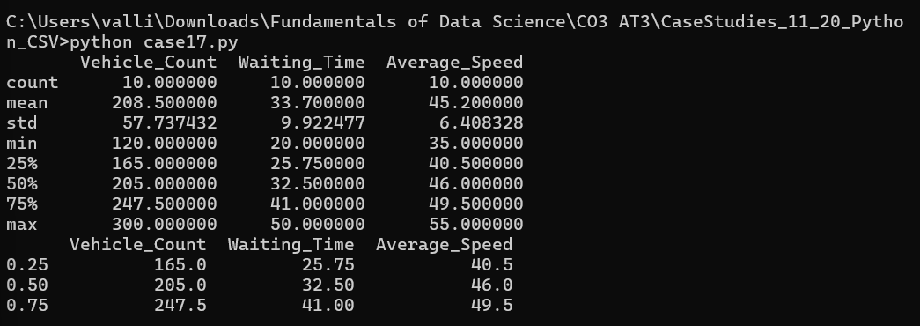
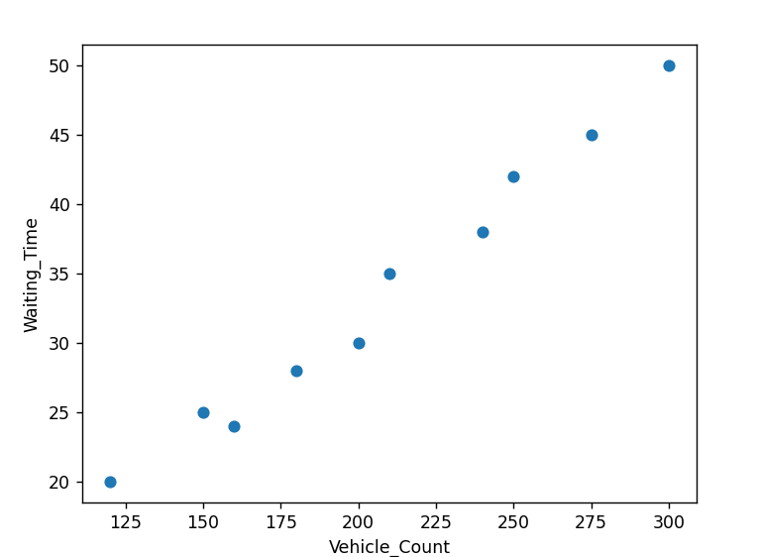
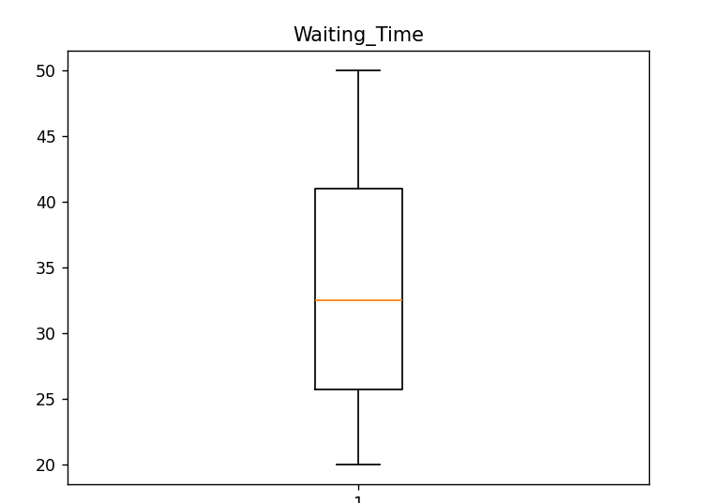
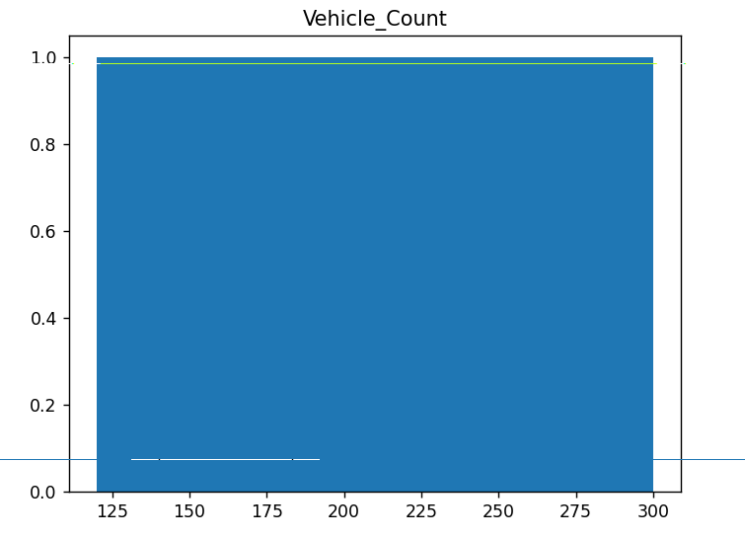

CASE STUDY 18 – Hotel Booking and Customer Review Analysis
Problem Understanding
A hotel chain has collected booking data, including room price, length of stay, customer rating, booking cancellation status, and service feedback score. The hotel management wants to improve customer satisfaction and optimize its pricing strategy. The study requires descriptive statistics, outlier detection, and hypothesis testing to understand customer behavior and enhance hotel services.

Application of Data Science Concepts
Data Science techniques help hotel management analyze customer booking patterns and improve service quality.
The following concepts are applied:
- Descriptive Statistics to summarize room price, length of stay, and customer ratings.
- Distribution Analysis to understand booking trends and customer satisfaction.
- Outlier Detection to identify abnormal room prices or unusually low customer ratings.
- Statistical Inference using hypothesis testing to compare customer ratings based on the length of stay.
- Data Visualization using histograms, box plots, and scatter plots.

A. Descriptive Statistics and Distribution Analysis
Descriptive statistics summarize hotel booking information and customer feedback.
Room Price
The following statistical measures should be calculated:
- Mean
- Median
- Mode
- Standard Deviation
- Variance
- Minimum
- Maximum
- Quartiles (Q1, Q2, Q3)
Interpretation
- The mean room price indicates the average price charged per booking.
- The median provides the typical room price and minimizes the effect of luxury room prices.
- The standard deviation measures the variation in room prices.
- Quartiles classify rooms into budget, standard, and premium categories.

Length of Stay
Statistical measures include:
- Mean
- Median
- Standard Deviation
- Quartiles
Interpretation
- The average length of stay indicates customer booking behavior.
- Higher variation suggests diverse travel purposes such as business trips and vacations.

Customer Ratings
Statistical measures include:
- Mean
- Median
- Standard Deviation
- Quartiles
Interpretation
- Higher average ratings indicate better customer satisfaction.
- The standard deviation measures consistency in customer reviews.

Distribution Analysis
Distribution analysis determines whether booking data follows a normal distribution or exhibits skewness.
Possible distributions include:
- Normal Distribution
- Positively Skewed Distribution
- Negatively Skewed Distribution
Examples:
- Room prices are often positively skewed because a few luxury rooms are much more expensive.
- Customer ratings are generally negatively skewed, as most guests tend to provide high ratings.
Suggested Visualizations
- Histogram of Room Prices
- Histogram of Customer Ratings
- Box Plot of Length of Stay
- Scatter Plot: Room Price vs Customer Rating

B. Outlier Detection and Interpretation
Outliers are observations that differ significantly from the majority of bookings.
Examples include:
- Extremely expensive luxury suites.
- Very low customer ratings due to poor service.
- Exceptionally long hotel stays.
- Incorrect booking records.
These outliers may:
- Distort the average room price.
- Increase the standard deviation.
- Produce misleading customer satisfaction analysis.
- Affect pricing strategy decisions.

Methods for Detecting Outliers
1. Interquartile Range (IQR) Method
Formula
$$IQR=Q_{3}-Q_{1}$$
Lower Limit
$$Q_{1}-1.5\left(IQR\right)$$
Upper Limit
$$Q_{3}+1.5\left(IQR\right)$$
Values outside these limits are considered outliers.

2. Z-Score Method
Formula
$$Z=\frac{x-μ}{σ}$$
If
$$∣Z∣>3$$
the observation is considered an outlier.

Handling Outliers
- Verify whether the value is a genuine luxury booking or data entry error.
- Retain genuine premium bookings for pricing analysis.
- Correct or remove inaccurate records.
- Analyze extremely low customer ratings separately to identify service issues.

C. Statistical Inference
The hotel wants to determine whether customers who stay more than three days give significantly different ratings compared with customers who stay for one or two days.

Step 1: Formulate Hypotheses
Null Hypothesis (H₀)
$$H_{0}:μ_{>3Days}=μ_{1-2Days}$$
There is no significant difference in customer ratings between guests staying more than three days and those staying one or two days.

Alternative Hypothesis (H₁)
$$H_{1}:μ_{>3Days}≠μ_{1-2Days}$$
There is a significant difference in customer ratings between the two groups.

Step 2: Significance Level
$$α=0.05$$

Step 3: Select Statistical Test
A Two-Sample t-Test is appropriate because customer ratings from two independent groups are being compared.
Test Statistic
$$t=\frac{{\overline{x}}_{1}-{\overline{x}}_{2}}{\sqrt{\frac{s_{1}^{2}}{n_{1}}+\frac{s_{2}^{2}}{n_{2}}}}$$

Step 4: Decision Rule
- If p-value < 0.05, reject the null hypothesis.
- Otherwise, fail to reject the null hypothesis.

Interpretation
If the null hypothesis is rejected:
- Length of stay significantly influences customer ratings.
- Hotel management should focus on improving services for long-stay guests.
- Pricing and loyalty programs can be designed accordingly.
If the null hypothesis is not rejected:
- There is insufficient statistical evidence that the length of stay affects customer ratings.

Analysis of Results
The hotel management can conclude that:
- Descriptive statistics summarize booking prices, stay duration, and customer ratings effectively.
- Distribution analysis identifies pricing and satisfaction trends.
- Outlier detection highlights unusual bookings and poor customer experiences.
- Hypothesis testing provides statistical evidence regarding the relationship between stay duration and customer satisfaction.

Practical Recommendations
- Offer loyalty rewards for long-stay customers.
- Monitor customer feedback regularly to improve service quality.
- Review pricing strategies for premium rooms.
- Investigate negative reviews immediately.
- Improve personalized services for extended stays.
- Use statistical dashboards to monitor customer satisfaction continuously.

Conclusion
Descriptive statistics and distribution analysis provide valuable insights into hotel booking behavior and customer satisfaction. Outlier detection identifies abnormal room prices and customer ratings, while hypothesis testing determines whether the length of stay significantly affects customer ratings. These analyses support data-driven pricing strategies and continuous improvement in hotel service quality.

Suggested Visualizations
- Histogram of Room Price
- Histogram of Customer Ratings
- Box Plot of Length of Stay
- Scatter Plot: Room Price vs Customer Rating
- Bar Chart: Average Customer Rating (More than 3 Days vs 1–2 Days)

Python Code
import pandas as pd
import matplotlib.pyplot as plt
data = {
"Room_Price": [2500, 3000, 2800, 4500, 5000, 3500, 4000, 3200, 2700, 4800],
"Length_of_Stay": [1, 2, 3, 4, 5, 2, 6, 3, 1, 4],
"Customer_Rating": [4.2, 4.4, 4.3, 4.7, 4.8, 4.5, 4.9, 4.4, 4.1, 4.8]
}
df = pd.DataFrame(data)
print(df.describe())
df["Room_Price"].hist()
plt.title("Room Price Distribution")
plt.xlabel("Room Price")
plt.ylabel("Frequency")
plt.show()
plt.boxplot(df["Length_of_Stay"])
plt.title("Length of Stay")
plt.ylabel("Days")
plt.show()
plt.scatter(df["Room_Price"], df["Customer_Rating"])
plt.title("Room Price vs Customer Rating")
plt.xlabel("Room Price")
plt.ylabel("Customer Rating")
plt.show()

Analysis of Results
- Average room price and customer rating summarize hotel performance.
- Distribution analysis identifies booking and pricing patterns.
- Outlier detection highlights luxury room bookings and unusually low customer ratings.
- Hypothesis testing determines whether the duration of stay significantly influences customer satisfaction.

Final Conclusion
The Hotel Booking and Customer Review Analysis demonstrates how descriptive statistics summarize room prices, length of stay, and customer ratings. Distribution analysis identifies booking trends, while outlier detection highlights unusual pricing and customer review values. Hypothesis testing determines whether customers staying more than three days provide significantly different ratings than customers staying one or two days, enabling the hotel to make data-driven decisions regarding pricing strategy, customer service, and guest satisfaction.

CASE STUDY 19 – Fitness App User Health Analysis
Problem Understanding
A fitness app has collected user health data, including daily steps, calories burned, workout duration, heart rate, sleep hours, and fitness goal completion. The app aims to study user activity patterns, improve health recommendations, and encourage healthier lifestyles. The study requires descriptive statistics, outlier detection, and hypothesis testing to identify health trends and support personalized fitness recommendations.

Application of Data Science Concepts
Data Science techniques help transform user fitness data into meaningful insights for improving health recommendations.
The following concepts are applied:
- Descriptive Statistics to summarize daily steps, calories burned, workout duration, and sleep hours.
- Distribution Analysis to study user activity patterns.
- Outlier Detection to identify abnormal workout duration and heart rate values.
- Statistical Inference using hypothesis testing to compare calories burned by users sleeping at least seven hours and users sleeping less than seven hours.
- Data Visualization using histograms, box plots, and scatter plots.

A. Descriptive Statistics and Distribution Analysis
Descriptive statistics summarize the health and fitness data collected from users.
Daily Steps
The following statistical measures should be calculated:
- Mean
- Median
- Mode
- Standard Deviation
- Variance
- Minimum
- Maximum
- Quartiles (Q1, Q2, Q3)
Interpretation
- The mean daily steps represent the average physical activity of users.
- The median provides the typical activity level while reducing the effect of unusually active users.
- The standard deviation measures variability in daily activity.
- Quartiles classify users into low, moderate, and highly active groups.

Calories Burned
Statistical measures include:
- Mean
- Median
- Standard Deviation
- Variance
- Quartiles
Interpretation
- Average calories burned indicate overall fitness activity.
- Large variation may reflect different workout intensities.

Workout Duration
Statistical measures include:
- Mean
- Median
- Standard Deviation
- Quartiles
Interpretation
- Average workout duration helps evaluate user exercise habits.
- Higher variation suggests different fitness routines among users.

Sleep Hours
Statistical measures include:
- Mean
- Median
- Standard Deviation
- Quartiles
Interpretation
- Average sleep duration indicates users' sleeping habits.
- Sleep data can be used to analyze its relationship with fitness performance.

Distribution Analysis
Distribution analysis determines whether health variables follow a normal distribution or exhibit skewness.
Possible distributions include:
- Normal Distribution
- Positively Skewed Distribution
- Negatively Skewed Distribution
Examples:
- Daily steps are often positively skewed because a few highly active users record exceptionally high step counts.
- Workout duration may also be positively skewed due to marathon training or extended exercise sessions.
Suggested Visualizations
- Histogram of Daily Steps
- Histogram of Calories Burned
- Box Plot of Workout Duration
- Scatter Plot: Sleep Hours vs Calories Burned

B. Outlier Detection and Interpretation
Outliers are observations that differ significantly from the majority of health records.
Examples include:
- Extremely long workout sessions.
- Abnormally high or low heart rates.
- Very low daily step counts due to inactivity.
- Incorrect readings from wearable fitness devices.
These outliers may:
- Distort the average workout duration.
- Increase the standard deviation.
- Produce misleading health recommendations.
- Affect predictive health models.

Methods for Detecting Outliers
1. Interquartile Range (IQR) Method
Formula
$$IQR=Q_{3}-Q_{1}$$
Lower Limit
$$Q_{1}-1.5\left(IQR\right)$$
Upper Limit
$$Q_{3}+1.5\left(IQR\right)$$
Values outside these limits are considered outliers.

2. Z-Score Method
Formula
$$Z=\frac{x-μ}{σ}$$
If
$$∣Z∣>3$$
the observation is considered an outlier.

Handling Outliers
- Verify whether the values are genuine or sensor errors.
- Retain genuine high-performance athletes' data.
- Remove incorrect or incomplete records.
- Analyze abnormal heart rate values separately for health monitoring.

C. Statistical Inference
The fitness app wants to determine whether users who sleep at least seven hours per day burn significantly more calories than users who sleep less than seven hours.

Step 1: Formulate Hypotheses
Null Hypothesis (H₀)
$$H_{0}:μ_{≥7Hours}=μ_{<7Hours}$$
There is no significant difference in calories burned between users sleeping at least seven hours and users sleeping less than seven hours.

Alternative Hypothesis (H₁)
$$H_{1}:μ_{≥7Hours}>μ_{<7Hours}$$
Users sleeping at least seven hours burn significantly more calories than users sleeping less than seven hours.

Step 2: Significance Level
$$α=0.05$$

Step 3: Select Statistical Test
A Two-Sample t-Test is appropriate because two independent groups of users are being compared.
Test Statistic
$$t=\frac{{\overline{x}}_{1}-{\overline{x}}_{2}}{\sqrt{\frac{s_{1}^{2}}{n_{1}}+\frac{s_{2}^{2}}{n_{2}}}}$$

Step 4: Decision Rule
- If p-value < 0.05, reject the null hypothesis.
- Otherwise, fail to reject the null hypothesis.

Interpretation
If the null hypothesis is rejected:
- Adequate sleep significantly improves calorie expenditure.
- The fitness app should recommend sleeping at least seven hours for better health outcomes.
- Personalized sleep and workout recommendations can be developed.
If the null hypothesis is not rejected:
- There is insufficient statistical evidence that sleep duration significantly affects calories burned.

Analysis of Results
The fitness app can conclude that:
- Descriptive statistics summarize daily activity and health indicators effectively.
- Distribution analysis identifies exercise and sleep patterns.
- Outlier detection highlights abnormal workout durations and heart rate values.
- Hypothesis testing provides statistical evidence regarding the relationship between sleep duration and calories burned.

Practical Recommendations
- Encourage users to maintain at least 7 hours of sleep every night.
- Provide personalized workout plans based on activity levels.
- Monitor abnormal heart rate values and notify users when necessary.
- Reward users who consistently achieve fitness goals.
- Use wearable device data for continuous health monitoring.
- Generate personalized health insights using statistical analysis.

Conclusion
Descriptive statistics and distribution analysis provide valuable insights into daily steps, calories burned, workout duration, and sleep habits. Outlier detection identifies abnormal health measurements, while hypothesis testing determines whether adequate sleep significantly improves calorie expenditure. These analyses support personalized fitness recommendations and encourage healthier lifestyles.

Suggested Visualizations
- Histogram of Daily Steps
- Histogram of Calories Burned
- Box Plot of Workout Duration
- Scatter Plot: Sleep Hours vs Calories Burned
- Bar Chart: Average Calories Burned (≥7 Hours Sleep vs <7 Hours Sleep)
Python Code
import pandas as pd
import matplotlib.pyplot as plt

# Sample Fitness App Dataset
data = {
"Daily_Steps": [6000, 7500, 8200, 9500, 11000, 12500, 9800, 8700, 7200, 10500],
"Calories_Burned": [220, 260, 310, 350, 420, 480, 390, 340, 280, 430],
"Workout_Duration": [25, 30, 35, 45, 55, 60, 50, 40, 28, 58],
"Sleep_Hours": [6, 7, 8, 7, 8, 9, 7, 6, 5, 8]
}

df = pd.DataFrame(data)

# Descriptive Statistics
print(df.describe())

# Histogram of Daily Steps
df["Daily_Steps"].hist()
plt.title("Daily Steps Distribution")
plt.xlabel("Daily Steps")
plt.ylabel("Frequency")
plt.show()

# Box Plot of Workout Duration
plt.boxplot(df["Workout_Duration"])
plt.title("Workout Duration")
plt.ylabel("Minutes")
plt.show()

# Scatter Plot
plt.scatter(df["Sleep_Hours"], df["Calories_Burned"])
plt.title("Sleep Hours vs Calories Burned")
plt.xlabel("Sleep Hours")
plt.ylabel("Calories Burned")
plt.show()

Analysis of Results
- Daily steps, calories burned, workout duration, and sleep hours provide a comprehensive summary of user health.
- Distribution analysis identifies patterns in physical activity and sleeping habits.
- Outlier detection highlights abnormal workout durations and heart rate values requiring further investigation.
- Hypothesis testing determines whether users sleeping at least 7 hours burn significantly more calories than those sleeping less than 7 hours, supporting personalized health recommendations.

Final Conclusion
The Fitness App User Health Analysis demonstrates how descriptive statistics summarize daily steps, calories burned, workout duration, and sleep hours. Distribution analysis identifies user activity patterns, while outlier detection recognizes abnormal workout durations and heart rate values that may affect health analysis. Hypothesis testing determines whether users sleeping at least seven hours per day burn significantly more calories than users sleeping less than seven hours, enabling the fitness app to provide evidence-based health recommendations and improve user wellness.

CASE STUDY 20 – Online Examination Performance Analysis
Problem Understanding
An educational institution has collected online examination data, including exam score, time taken to complete the test, number of attempts, internet interruption count, and student feedback. The institution aims to evaluate student performance, improve the online assessment system, and ensure fair examination practices. The study requires descriptive statistics, outlier detection, and hypothesis testing to identify performance patterns and support evidence-based academic decisions.

Application of Data Science Concepts
Data Science techniques help educational institutions analyze examination performance and improve assessment quality.
The following concepts are applied:
- Descriptive Statistics to summarize exam scores, completion time, and number of attempts.
- Distribution Analysis to understand student performance patterns.
- Outlier Detection to identify unusually short completion times or extremely high numbers of attempts.
- Statistical Inference using hypothesis testing to compare exam scores between students with fewer internet interruptions and those with frequent interruptions.
- Data Visualization using histograms, box plots, and scatter plots.

A. Descriptive Statistics and Distribution Analysis
Descriptive statistics summarize online examination performance and student behavior.

Exam Scores
The following statistical measures should be calculated:
- Mean
- Median
- Mode
- Standard Deviation
- Variance
- Minimum
- Maximum
- Quartiles (Q1, Q2, Q3)
Interpretation
- The mean exam score represents the average student performance.
- The median provides the central exam score and is less affected by extremely high or low marks.
- The standard deviation measures variation in student performance.
- Quartiles divide students into low, average, and high-performing groups.

Completion Time
Statistical measures include:
- Mean
- Median
- Standard Deviation
- Quartiles
Interpretation
- Average completion time indicates the typical duration required to finish the examination.
- High variation suggests differences in student preparation or question difficulty.

Number of Attempts
Statistical measures include:
- Mean
- Median
- Standard Deviation
- Quartiles
Interpretation
- The average number of attempts indicates how often students retake the examination.
- Higher values may suggest difficult questions or insufficient preparation.

Distribution Analysis
Distribution analysis determines whether examination data follows a normal distribution or exhibits skewness.
Possible distributions include:
- Normal Distribution
- Positively Skewed Distribution
- Negatively Skewed Distribution
Examples:
- Exam scores often follow an approximately normal distribution.
- Number of attempts may be positively skewed, as most students complete the exam in one attempt while only a few require multiple attempts.
- Completion time may also be positively skewed if a few students take significantly longer than average.

Suggested Visualizations
- Histogram of Exam Scores
- Histogram of Completion Time
- Box Plot of Number of Attempts
- Scatter Plot: Completion Time vs Exam Score

B. Outlier Detection and Interpretation
Outliers are observations that differ significantly from the majority of examination records.
Examples include:
- Extremely short completion times indicating possible random guessing or malpractice.
- Very high numbers of attempts.
- Exceptionally low or high exam scores.
- High internet interruption counts caused by network failures.
These outliers may:
- Distort the average exam score.
- Increase the standard deviation.
- Produce misleading conclusions about student performance.
- Affect the fairness of assessment analysis.

Methods for Detecting Outliers
1. Interquartile Range (IQR) Method
Formula
$$IQR=Q_{3}-Q_{1}$$
Lower Limit
$$Q_{1}-1.5\left(IQR\right)$$
Upper Limit
$$Q_{3}+1.5\left(IQR\right)$$
Values outside these limits are considered outliers.

2. Z-Score Method
Formula
$$Z=\frac{x-μ}{σ}$$
If
$$∣Z∣>3$$
the observation is considered an outlier.

Handling Outliers
- Verify whether the observation is genuine or caused by technical issues.
- Investigate unusually short completion times for possible academic misconduct.
- Remove incorrect records if they result from data entry errors.
- Analyze internet interruption records separately to understand technical problems.

C. Statistical Inference
The institution wants to determine whether students with fewer internet interruptions score significantly higher than students with frequent interruptions.

Step 1: Formulate Hypotheses
Null Hypothesis (H₀)
$$H_{0}:μ_{FewInterruptions}=μ_{FrequentInterruptions}$$
There is no significant difference in exam scores between students with fewer internet interruptions and those with frequent interruptions.

Alternative Hypothesis (H₁)
$$H_{1}:μ_{FewInterruptions}>μ_{FrequentInterruptions}$$
Students experiencing fewer internet interruptions score significantly higher than students experiencing frequent interruptions.

Step 2: Significance Level
$$α=0.05$$

Step 3: Select Statistical Test
A Two-Sample t-Test is appropriate because exam scores from two independent groups are being compared.
Test Statistic
$$t=\frac{{\overline{x}}_{1}-{\overline{x}}_{2}}{\sqrt{\frac{s_{1}^{2}}{n_{1}}+\frac{s_{2}^{2}}{n_{2}}}}$$

Step 4: Decision Rule
- If p-value < 0.05, reject the null hypothesis.
- Otherwise, fail to reject the null hypothesis.

Interpretation
If the null hypothesis is rejected:
- Internet interruptions significantly affect student performance.
- The institution should improve network infrastructure and provide contingency measures.
- Online examination platforms should support automatic reconnection and response recovery.
If the null hypothesis is not rejected:
- There is insufficient statistical evidence that internet interruptions significantly influence exam scores.

Analysis of Results
The educational institution can conclude that:
- Descriptive statistics summarize exam scores, completion time, and number of attempts effectively.
- Distribution analysis identifies student performance patterns.
- Outlier detection highlights unusual examination behavior and technical issues.
- Hypothesis testing provides statistical evidence regarding the impact of internet interruptions on examination performance.

Practical Recommendations
- Improve internet connectivity for online examinations.
- Introduce automatic answer-saving mechanisms.
- Provide additional time for students affected by genuine network failures.
- Monitor unusually short completion times to detect possible malpractice.
- Analyze student feedback to improve the online examination platform.
- Regularly evaluate examination data using statistical techniques to enhance fairness and reliability.

Conclusion
Descriptive statistics and distribution analysis provide valuable insights into exam scores, completion time, and number of attempts. Outlier detection identifies unusual examination behavior and technical issues, while hypothesis testing determines whether students with fewer internet interruptions perform significantly better than students with frequent interruptions. These analyses support data-driven improvements in online examination systems, ensuring fair assessment and enhanced student performance.

Suggested Visualizations
- Histogram of Exam Scores
- Histogram of Completion Time
- Box Plot of Number of Attempts
- Scatter Plot: Completion Time vs Exam Score
- Bar Chart: Average Exam Score (Few Internet Interruptions vs Frequent Internet Interruptions)

Python Code
import pandas as pd
import matplotlib.pyplot as plt

# Sample Online Examination Dataset
data = {
"Exam_Score": [72, 78, 85, 90, 68, 88, 92, 80, 76, 84],
"Completion_Time": [55, 60, 48, 45, 70, 50, 43, 58, 65, 52],
"Attempts": [1, 1, 1, 1, 2, 1, 1, 2, 2, 1],
"Internet_Interruptions": [0, 1, 0, 0, 3, 1, 0, 2, 2, 1]
}

df = pd.DataFrame(data)

# Descriptive Statistics
print(df.describe())

# Histogram of Exam Scores
df["Exam_Score"].hist()
plt.title("Exam Score Distribution")
plt.xlabel("Exam Score")
plt.ylabel("Frequency")
plt.show()

# Box Plot of Attempts
plt.boxplot(df["Attempts"])
plt.title("Number of Attempts")
plt.ylabel("Attempts")
plt.show()

# Scatter Plot
plt.scatter(df["Completion_Time"], df["Exam_Score"])
plt.title("Completion Time vs Exam Score")
plt.xlabel("Completion Time (minutes)")
plt.ylabel("Exam Score")
plt.show()

Analysis of Results
- The average exam score, completion time, and number of attempts summarize overall student performance.
- Distribution analysis identifies whether student scores follow a normal pattern or exhibit skewness.
- Outlier detection helps identify abnormal examination behavior and technical issues affecting assessment.
- Hypothesis testing determines whether students experiencing fewer internet interruptions achieve significantly higher exam scores, supporting improvements in the online examination system.

Final Conclusion
The Online Examination Performance Analysis demonstrates how descriptive statistics summarize exam scores, completion time, and number of attempts, while distribution analysis identifies performance patterns. Outlier detection highlights unusual examination behavior and technical issues, and hypothesis testing determines whether students with fewer internet interruptions score significantly higher than those with frequent interruptions. These findings enable educational institutions to improve online assessment quality, fairness, and student performance.

